2nd September 2020

Dear Parents/Carers

I am writing today with full details about the routines and expectations that will be in place when term starts later this week.

The purpose of everything that we have put in place is to allow us to deliver education as effectively as we can. Please discuss returning to school with your child in accordance to the guidance notes below.

Students return to School: Guidance notes for September 2020

When will school reopen?

The Jubilee Academy will re-open to all students on Thursday 3rd September 2020.

All students are expected to return to school unless they, or anyone in their household, are showing covid-19 symptoms or have been tested positive in the last 10 days.

If your child is unable to attend, please inform us by 9.15am at the very latest.

It is an expectation that both students and parents/carers will work in partnership with schools to support procedures to manage suspected cases of coronavirus in the following way:

- Notify the school if your child has an impaired immune system, a medical condition that means that they are vulnerable to infection, or is clinically extremely vulnerable
- Inform the school if any member of your household or your child is displaying symptoms
- Not to send your child into school if they are displaying symptoms
- Arrange immediately for your child to have priority testing and engage with the NHS Test and Trace process
- As soon as the test result is known we would ask you contact the school
- Provide details of anyone they have been in close contact with if they were to test positive for coronavirus or
- if contacted by NHS Test and Trace, to self-isolate if they have been in close contact with someone who develops coronavirus (COVID-19) symptoms, or someone who tests positive for coronavirus (COVID-19)

How will the risk of spreading the virus be kept to an absolute minimum?

Each student will be placed into a bubble to help minimise and control the spread of covid-19. The members of each bubble will enter and leave school at differing times to the other bubbles, and each student must stay with their assigned bubble for the day.

Students will be taught in their assigned bubble and will have their break and lunch slots within their allocated bubble. Each bubble will have specific time slots for toilet break during break and lunch time. The toilets will be cleaned before use by the next bubble and at the end of every day.

It is an expectation that students will need to wash their hands upon arrival to school each morning before going to their lessons, and throughout the day. We will have a hand washing station in the canteen to facilitate this. Students will also be expected to sanitise their hands upon entering and leaving the classroom. In addition, students will be expected to wear face masks in communal areas and will be expected to maintain the social distancing rules where possible.

Classrooms have been cleared of unnecessary furniture so that there is as much space as possible and to allow safe practice of social distancing. Students will stay at their designated desks throughout their lessons, and the desks will be cleaned thoroughly between class changes. Teachers will not circulate amongst the students but will remain at the front of the room, 2 metres away.

There will be no use of shared learning resources such as textbooks, pens, pencils. Each student will be assigned their own personal pen/pencil case to use during school and they will not need to bring their own equipment into school.

We will continue to carry out our routine searches in the mornings. Students will be responsible for placing all their personal and electronic devices in their individual pouches, which will be stored away until the end of the school day. They will also be responsible for emptying their pockets and declaring any items that are deemed prohibited according to the school behaviour policy.

Any student who does not show sufficient regard for the wellbeing of others, and does not comply with the school’s behaviour policy, will be removed from the session and a sanction will be applied in accordance with the school’s behaviour policy.

Face Coverings
From the start of term this September 2020, staff will be asked to to wear a visor face covering in the classroom and in all communal areas in the school.

Students will be also be asked to wear face coverings in communal areas. Please ensure the mask is plain with no logos or inappropriate designs. Please let the school know if you consider your child to be exempt from wearing a face covering in accordance with the reasons based on the Government Guidance.

The reasons are:
- My child cannot put on, wear or remove a face covering because of a physical or mental illness, or impairment, or disability
- Putting on, wearing, or removing a face covering will cause severe distress to my child
- My child will be speaking to, or providing assistance to, someone who relies on lip reading, clear sound or facial expressions to communication
- To avoid harm or injury, or the risk of harm or injury, to my child or others

Arrangements for your child if they become unwell at school

We will contact you and ask you to collect your child immediately.
- You must arrange immediately for your child to have priority testing and engage with the NHS Test and Trace process.
- As soon as the test result is known we would ask you contact the school.
- If the school has 2 or more confirmed cases within14 days, we will seek advice from the local protection health team.

How much time will the students be in school for, and what will they study?

All students will be back in school to study the full curriculum, including Maths, English and Science, on a full-time basis everyday Monday to Friday.

If your child is unable to attend, please inform us by 9.15am at the very latest.

To help minimise and control the spread of the virus, all students have been placed in a bubble. Each bubble has a specific start and finish time and its important you pay special attention to your child’s bubble start and finish times.

- Bubble A: Years 7 and 8 students only.
They are expected to start school at 9:00am and finish at 3:10pm each day.

- Bubble B: Years 9 and 10 students only.
They are expected to start school at 9:20am and finish at 3:30pm each day.

- Bubble C: Year 11 students only.
They are expected to start school at 9:40am and finish at 3:50pm each day

At the start of the first lesson each day, staff will provide important and necessary information around expectations, behaviour, attendance, and safeguarding protocols, as well as any pastoral updates.

We will continue to have assembly on Mondays and Fridays, but this will be done virtually via Teams to minimise risk of mixing bubbles. Lessons will be taught by each student’s assigned teacher for these subjects, as it would be prior to lockdown.

Does this mean that online learning is over?

The online learning platform will continue to take place and it will be used to compliment the school’s curriculum offer to provide a blended learning experience for students. We are working to improve our current online learning platform and from September we will be introducing Microsoft Teams to all students.

This will be our main online platform for homework, catch up lessons, interventions and to supply feedback on different learning opportunities. Students will be offered training and guidance from the first week in September 2020 around the use of Microsoft Teams including strict user protocols.

It will be our expectation that any students who isolate due to Coronavirus symptoms will be expected to pick up the curriculum through our remote online education platform and continue their learning from home.

What should the students bring into school with them and what should they wear?

Students should continue to wear their school uniform. Uniforms do not need to be cleaned any more often than usual, nor do they need to be cleaned using methods which are different from normal.

Students may bring in snacks and drinks for their own personal consumption. If students are bringing a packed lunch, this needs to be in a plastic bag with their name on it. Student should not bring any other items from home, including their school bag. A pencil case will be provided.

On arrival, and in line with government guidance, students will be asked to continue to wear face coverings in communal areas. Once in the classroom, they will be asked to remove their face covering.

All classrooms will be surface cleaned between class changes, and a deeper clean conducted every morning.

How will Students get to and from school?

If possible, students should try and walk or cycle to school, or be driven in. If they need to take public transport, we have tried to reduce the potential for exposure to the virus by starting and ending the school day at various times.

If students use public transport, he/she will need to wear face covering whilst travelling, and this is the same if they are planning to go into shops. This is a legal requirement and failure to adhere to this guidance could result in fines.

According to TfL, buses, as the most common transport mode for schoolchildren, are likely to see the biggest increase in demand in September. Thus plans include dedicating a number of buses for school travel on high-frequency routes that TfL has forecasted to be the busiest. These services will be clearly signed, and information will be posted at bus stops and online.

Pickups and drop offs can only be done on the side roads or outside the school. Parent/carers may not enter the school premises other than in emergency situations.

When will everything return to normal?

It is too early to tell what will happen from September, but we will endeavour to let you know as soon as we have any specific information to share on these issues.

Will the students get to spend time with their friends?

In normal circumstances, the interaction between students is a hugely important part of school life. However, these are by no means normal circumstances. We have put students together in bubbles and we cannot allow students from different bubbles to socialise during school. This is an effort to keep everyone safe and to minimise the risk and spread of the virus. Therefore, we have introduced staggered start and finish times, including breaks and lunch times, to help manage and minimise contact between bubbles and maintain social distancing wherever possible.

Behaviour and Expectations

To help stay alert, minimise the risk and to stop the spread of the virus, we are introducing some new rules and guidelines which must always be followed. Students will be expected to sign a revised code of conduct upon their return to school from September 2020:
- You must follow changes to the behaviour and attendance policy, especially as it relates to the new points system for detentions
- You must follow all changes in routines for arrival or departure to school
- You must follow instructions on hygiene, such as hand washing and sanitising
- You must follow instructions on staying within your group or bubble
- You must follow rules about not sharing any equipment or other items
- You must follow expectations about breaks, including where you can and cannot go
- You must follow instructions regarding the use of toilets (one in one out system)
- You must move around the school sensibly and follow instructions (for example, one-way systems, out of bounds area)
- You must follow expectations about sneezing, coughing, tissues, and disposal (‘catch it, bin it, kill it’) and avoiding touching your mouth, nose and eyes with your hands
- You must tell an adult if you are feeling unwell
- Coughing or spitting at or towards any other person in a deliberate manner will not be tolerated at all and there will be serious consequences
- You must wear face covering, unless exempt to do so, in all communal areas
- If you are unable to follow the guidelines above, parents will be informed, and you will not be able to remain at school.

Health, Hygiene & Safety Reminders

Students will be asked to wash or sanitise their hands several times a day: on entry and when leaving school; before and after break and lunch; in between transition times etc. Please make sure you practice washing hands thoroughly at home with your child. Hand sanitiser stations will be made available in all classrooms and in many communal areas around the school.

Germs can live for several hours on tissues , so any time a student wants to sneeze or cough they will need to ‘catch it’ in a tissue and ‘bin it’ to ‘kill it’ in the clearly marked campaign bins and remember to wash hands straight after.

Students should avoid touching their eyes, nose, mouth, or faces. They should try and keep their hands to themselves and avoid touching any surfaces if they do not need to. This includes stair rails, doors, walls, etc. They should follow all one-way systems around the school.

All students MUST keep their distance from others and be respectful of other people’s spaces.

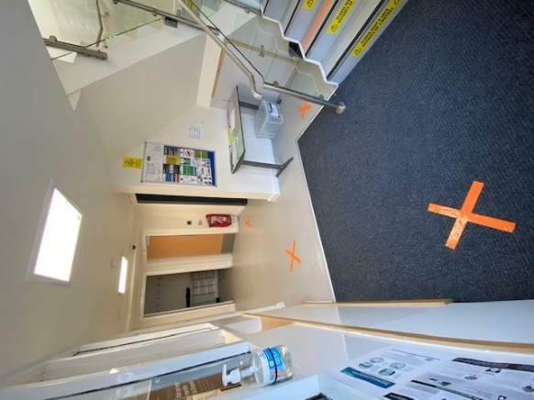 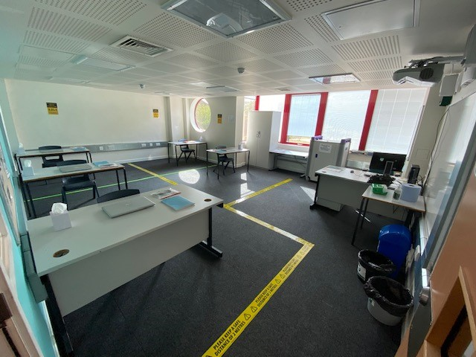
Examples of marking and school changes to ensure student safety.

We will be talking students through these procedures in the first few days of the year, and will support them as they get used to them. However, they are now part of our behaviour expectations and sanctions will ultimately be applied to students who do not follow the rules, which are there for everyone's benefit.

Cleaning regimes

In accordance with government guidance, the school has procured an additional cleaner to support the school with transitional cleaning between lessons, break times, lunch times, toilet breaks and any other additional activities. A deeper clean will be conducted every morning, and further in depth contamination cleaning arranged accordingly if there are any positive cases reported to the school.

Visitor Management

In accordance with our infection controls, no visitors will be allowed on site without
a prior appointment with the school and this includes parents/carers and then only
if the following criteria is met:

Please do not come into school if you or someone in your household is displaying any of the following coronavirus (COVID 19) symptoms:

- a new and continuous cough,
- a high temperature and /or
- a loss or change to your sense of smell or taste
Or
- have tested positive in the last 10 days
If you are requested to come and pick up your child you will be asked to wait on the 2 metre markers outside this entrance until your child is released.

Emotional wellbeing and support

We have a shared responsibility as staff, students and parents to being understanding and accepting that everyone will have had different experiences over the past few months and will have a wide range of different feelings about returning to school. This extends to adults as well as students.

We encourage you to talk to your child about how they are feeling, encouraging them to share their feelings with their friends and adults at school.

The school will be offering a number of intervention programmes in partnership with external agencies in addition to the school’s pastoral support to help students with their transition back to school.

As always, we are contactable if you have any safeguarding concerns. Please email, SafegurdingGroup@thejubileeacademy.onmicrosoft.com

Further safeguarding information and guidance can be found on the school website at: https://www.thejubileeacademy.org.uk/safeguarding

Further Resources and guidance regarding the corona virus can be found on the school website at: https://www.thejubileeacademy.org.uk/coronavirusinfo

Parents are also encouraged to visit gov.uk/backtoschool for information and practical guidance to help them plan for their children’s return to school.

For all other concerns, please email: info@thejubileeacademy.org.uk

Kind regards,
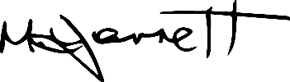
Michael Jarrett
Head of School

