

11th June 2026

Dear Parents/carers

Please be advised that the school is no longer using Sims and we have now moved over to Bromcom.

We will be sending out details shortly on how you can log into Bromcom so you can look at your child’s attendance, behaviour and achievement points and homework.

Please note we are no longer accessing Sims. If you need to contact us, please can you email info@thejubileeacademy.org.uk or call us on 0203 096 1221.

Thank you for your patience while we set up this new system.

Yours faithfully

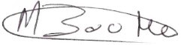
Marlon Boothe (NPQH)
Headteacher
The Jubilee Academy

