5th June 2026

Dear Parent/Carer,

I am writing to inform you that on Tuesday 16th June 2026, school will be closing early
for all students. The year 11 Graduation ceremony is taking place for our year 11s and their parents/carers.

Therefore, pupils will be dismissed from 1.15pm.

Thank you in advance for your support. If you have any questions, please feel free to contact
the school on 0203 096 1221.

Yours sincerely,

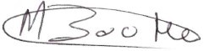
Marlon Boothe (NPQH)
Headteacher
The Jubilee Academy



