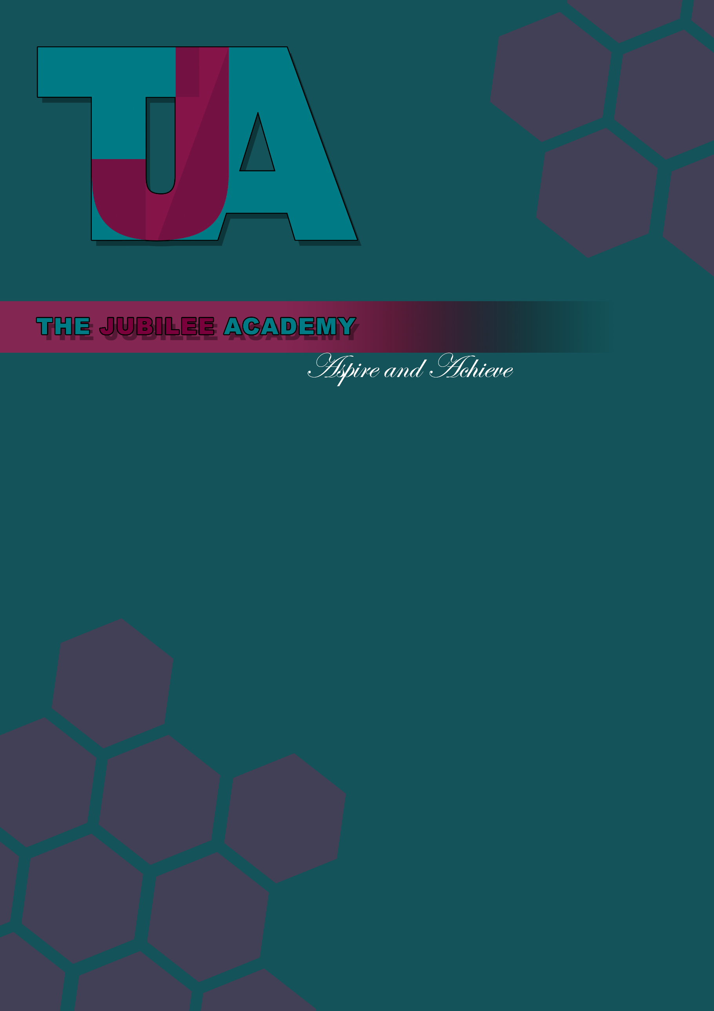

Title: Admissions and Referral Arrangements

Date Approved: September 2013

Date Last Reviewed: July 2024

Status: Statutory

Delegation: Head of School

Review Frequency: Annually

Policy Locations: Website/Staff Shared Drive/Hard Copy

Next Review Date: July 2025

Policy Locations: Website/Staff Shared Drive/Hard Copy
Next Review Date: June 2020




Admissions and Referral Arrangements for 2024/25

The Jubilee Academy is an alternative provision free school focused upon improving opportunities and outcomes for students who are not fulfilling their potential within mainstream schools.
The aim of the Academy is to facilitate the re‐engagement of its students into mainstream education and (if relevant) progression to employment or further education.
The Jubilee Academy will provide education for students aged 11 – 16 (Year 7 to Year 11).
Admission to The Jubilee Academy will be through the referral process outlined in this policy. Referrals may be made at any time throughout the year.
The admission of a student should not adversely affect the education and behaviour of the students already attending The Jubilee Academy. Consideration will be given by the Academy to the type of difficulties and behaviours exhibited by the student and the likely effects upon the students and staff at The Jubilee Academy if that student joined Jubilee.

Students supported at The Jubilee Academy
The Jubilee Academy is for students who need additional support over and above what is available in mainstream schools in order to fulfil their potential.
Admission to the Academy is for students where there is demonstrable evidence of one or more of the following:
- Students who are showing a level of disengagement from, or inability to cope effectively within, mainstream provision which is placing them at risk of permanent exclusion
- Students who are pregnant or young parents
- Students who have been out of education for a prolonged period of time, including for medical reasons
- Students who have insufficient or inconsistent attendance
- Students where a Managed Move to another mainstream school has not been successful
- Students who have been permanently excluded from one mainstream school
- Students who are experiencing significant bullying (including cyber-­‐bullying)
- Students who are exposed to abuse, or considered to be at risk of abuse
- Students with additional needs that means they are struggling to cope with the curriculum and organisation of their mainstream school
The Jubilee Academy is not a Pupil Referral Unit and is not envisaged to be suitable for students with significant behavioural issues or a history of violent conduct.

[Note – a ‘managed move’ means where a student has transferred from one mainstream secondary school to another through a co-­‐ordinated process involving consideration of their circumstances by a Fair Access Panel or something similar

Student numbers
The Jubilee Academy will admit up to the following full-­‐time equivalent students at any one time:

Year Group | 2013/14 | 2014/15 and subsequent years
Key Stage 3 (Years 7 – 8) | 40 | 25
Key Stage 4 (Years 9, 10 and 11) | 60 | 60

Students will not be admitted in any Key Stage above the full-­‐time equivalent number above unless exceptional circumstances apply.

Process for admission to The Jubilee Academy
The Jubilee Academy will only admit a child of compulsory school age for a placement at or ongoing support from the Academy under the following circumstances:

  - If referred by a local authority where the local authority has a duty to that child under section 19 of the Education Act 19961
  - If referred by a maintained school or academy where the school or academy has a duty under section 100 of the Education and Inspections Act 20062
  - Referred by a maintained school under powers set out in section 29(A) of the Education Act 20023
  - Referred by an Academy Trust under the provisions within their Articles of Association.
All referrals for placements at or ongoing support from The Jubilee Academy must be made using the Referral Form. Except in exceptional circumstances, an application will not be considered until all the information required by the Referral Form is provided. Applications will not be considered unless and until the commissioner enters into a Commissioning Agreement with The Jubilee Academy, which includes confirmation of their acceptance of the funding requirements per student.
All referrals will be considered carefully by The Jubilee Academy on their individual merit. The Jubilee Academy reserves the right to seek additional information from appropriate agencies as part of considering any referral.
The Academy will consider the following factors when determining whether to admit the student:

1 Section 19 of the Education Act 1996, and regulations made under that section, requires a local authority to make arrangements (from the sixth day of exclusion where a pupil has been permanently excluded) for the provision of suitable, full time (unless there are medical reasons as to why this would not be appropriate) education at school or otherwise who, for a range of reasons, would otherwise be without such education
2 Section 100 of the Education and Inspections Act 2006 requires maintained schools and Academies to
arrange full-time education for pupils on a fixed period exclusion of more than five days from the sixth day of the exclusion
3 Section 29A of the Education Act 2002 provides that governing bodies of maintained schools may direct a
pupil off-site “for the purpose of receiving educational provision which is intended to improve the behaviour of the pupil”

- Whether there is sufficient evidence of the student being eligible for Jubilee in accordance with the ‘Students supported at The Jubilee Academy’ section above
- The extent to which The Jubilee Academy has the expertise to support the student more effectively than the commissioner
- Whether accepting the referral would have a detrimental impact upon
  - The education provided to other students, including consideration of group sizes
  - The well-­‐being and health and safety of students and staff already at The Jubilee Academy
The decision about whether to admit a student to The Jubilee Academy will be made by the Headteacher or their authorised representative. The decision, and the reasons for it, will be provided in writing to the commissioner.
If admission is agreed, the Head of School (or their authorised representative) will agree the start date with the commissioner, and the commissioner will provide all required information to The Jubilee Academy in advance of that start date, and the Headteacher (or their authorised representative) and the commissioner will agree the process for assessment, target setting, and reporting.

Pupil registration
All students who are referred by schools / academies will be dual-­‐registered, with the lead registration held by the school which made the referral.
All students who are referred by a Local Authority will be registered at The Jubilee Academy.

Over‐subscription criteria
If there are more referrals than places available, priority will be given to referrals in the following order:
- Students who are or were previously looked after by a local authority (as defined by the Children Act 1989)
- Students who attend a state-­‐funded school situated within the London Borough of Harrow
- Distance from The Jubilee Academy as measured in a straight line from home to the centre point of the school site. [Note – this is the same distance criterion as used for mainstream schools]

Objections or complaints
Any objections to this policy or its application should be raised with the Academy through its normal complaints process. If the objector is not satisfied with the resolution, they are able to object to the Education Funding Agency (EFA) or its success

