

PASTORAL TEAM


Scared?
Having a difficult Worried? time?
Come speak to us.
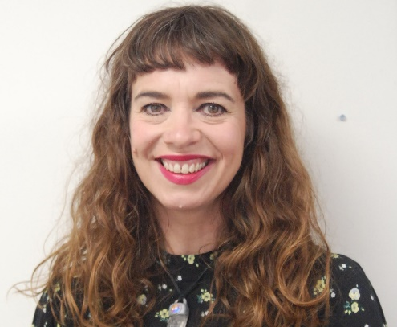
PA, Admissions Pastoral Officer
MRS GLOADY
Pastoral Manager and Safeguarding Officer
MS JERMY
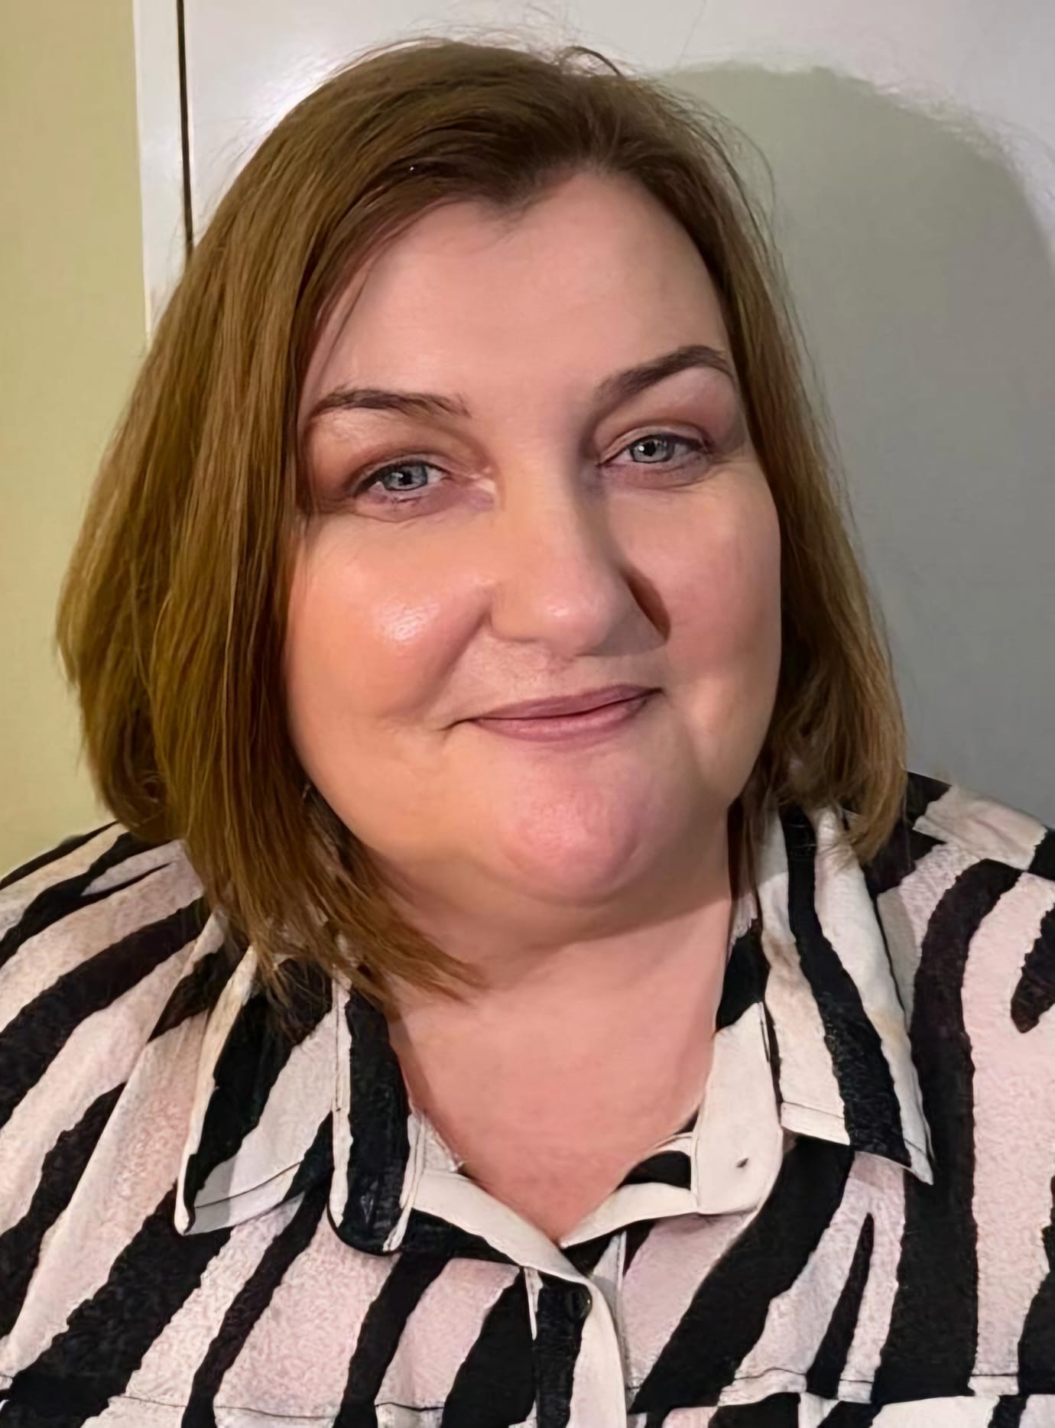

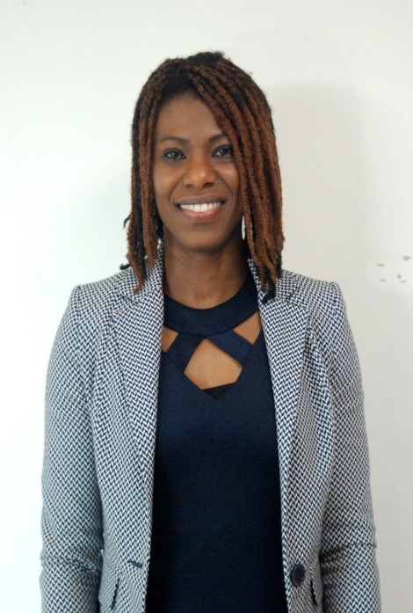
Assistant Headteacher, SENCO & DDSL
MS FORRESTER
Attendance Officer
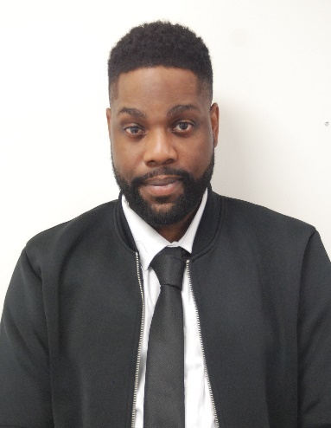
PE Teacher & Learning Mentor

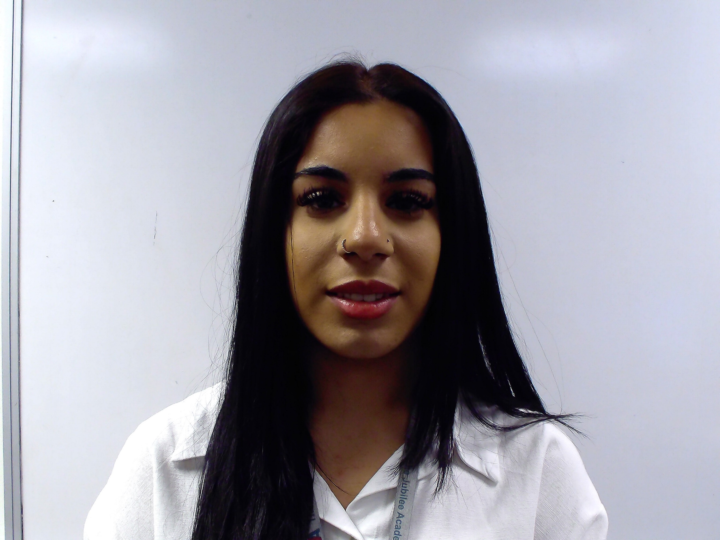

MISS MATTAR
MR ODIMAYO

