
Aspire and Achieve

Gazette

Spring Term 2026

Welcome to issue #27

Welcome to the latest edition of
The Jubilee Gazette in which we are pleased to update you on what has been happening at The Jubilee Academy.

Page 2 – Message from the Head
Page 3-5 – News & Update
Page 7 – Safeguard & pastoral Update
Page 8 – Important Dates/Gallery


Message from Head of School

Dear Parents, Carers and Students,
It was great to see the Year 11’s settled and working well in their winter mock examinations.
We have had a very busy term. Some of the students have been rewarded for their good behaviour and attendance with an assembly, positive phone calls and post cards home.
A survey for Harrow Council was completed by a large majority of our students called “How are you” Results showed a significant number of our students felt safe at school when compared to responses from other students across the Borough. They also reported that they felt most teachers care about them and there is at least one staff member they can go to if they have a problem which is inline with other student responses across the Borough.

We are proud to be part of THRIVE, a trauma informed practice to support our learners.
We have had another successful Motivational conference for our Year 11’s. This allows past students to share their journeys and experiences. This helps the current Year 11’s to make better choices about their education and lifestyle.
Warm Regards,

Marlon Boothe (NPQH)
Headteacher

News & Update

We have made slight changes to the school timings and to the uniform policy. The changes have been successful and the students seem more settled.

Year 11 students have been busy with college applications and post 16. They continue to be supported by the careers team.We have an exam awareness session coming up for our Year 11 students and parents. This is a very important session and is mandatory for parents. We will provide more details closer to the time.

GCSE’s begin for Year 11 in May 2026. Please have discussions with your child about arriving on time for their exams and being prepeared so their attendance is in line with school expectations. A full timetable of your childs exams will be available at the exam awareness session.

TIPS FOR GCSE PREPARATION
Create a revision timetable, plan your time
Find a study area somewhere quiet, calm and free of distractions.
Turn off notifications on your phone.
Don’t forget to have a study break.







Safeguarding

Nothing is more important to us than our students’ safety. If you have any concerns about your child or any other child at The Jubilee Academy, please contact us.
Students are issued a Safeguarding Handbook when they join TJA letting them know who to contact to for support. For more information on Safeguarding see our website: www.thejubileeacademy.org.uk/safeguarding.
We are contactable during the holidays. If you have any Safeguarding concerns, please contact us. Call 0203 096 1221 or email Safeguarding@thejubileeacademy.org.uk
Our Pastoral Team are:

Ms Jermy Mr Odimayo
Pastoral Manager/ Safeguard Officer Learning Mentor

Our Safeguarding Contacts are:

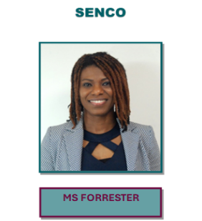
Ms Rockell Mr Artrey Ms Forrester Designated Safeguard Lead Deputy Safeguard Deputy Safeguard


Lead Governor for Safeguarding
Mrs R Cozens

Update from SAFEGUARDING/PASTORAL

Below is a list of the outside agencies we use to support our students.
- “Talk it out” Counselling Service

- Compass - Substance Misuse Support

- Stop Smoking Cessation Programme

- Mosaic – LGBT

- Harrow Horizons – Wellbeing and mental health

- Samaritans

- Synergy

- Brooks – Sex health & relationships

- KOOTH
- Educational Psychologists

- Ignite – Support for young people

RSHE
We have covered a variety of topics this term in RSHE. Topics we have looked at include careers, laws surrounding work and money.
We continue to work with Brook Education also covering topics including Online Safety, Consent, Healthy Relationships and Self Esteem.
If you would like more information about Brook you can visit their website on www.brook.org.uk.

We continue to work with Synergy Theatre Project group exploring serious topics and issues through drama and presentations.
Participation results in increased confidence, development of new creative skills, greater awareness of criminal activity and its consequences, better teamworking and, in some cases, re-engagement with mainstream education.
www.synergytheatreproject.co.uk

Important dates 2026

Parents evening Thursday 22nd January 2026 3.45pm-5.45pm
Half Term Monday 16th February 2026 – Friday 20th February 2026

TERM dates 2026

Spring Term 2026
Monday 5th January 2026 – Friday 13th February 2026
Half Term Monday 16th February 2026 – Friday 20th February 2026
Monday 23rd February 2026 – Friday 27th March 2026
(Good Friday 3rd April 2026, Easter Monday 6th April 2026)
Inset days: Monday 5th January 2026.

Summer Term 2026
Monday 13th April 2026 – Friday 22nd May 2026
Half Term Monday 25th May 2026 – Friday 29th May 2026
Monday 01st June 2026 – Monday 20th July 2026

Post planning day: Monday 13th April 2026

Inset days: Tuesday 14th April 2026.

Well-being day: Friday 17th July 2026

Post planning day: Monday 20th July 2026

Gallery
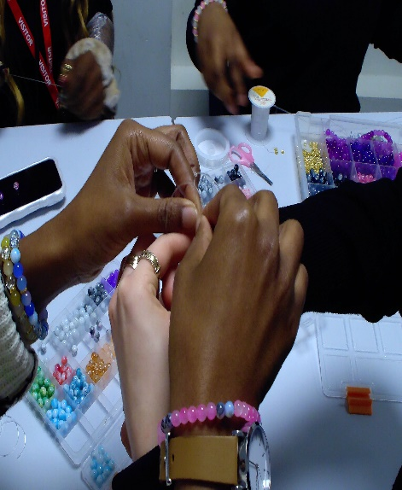
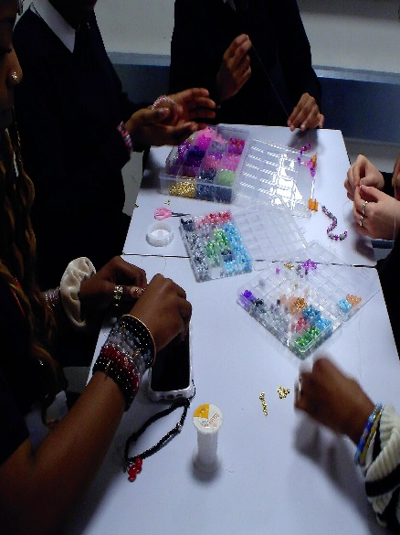 BRACELET making


Christmas lunch


A full list of dates can be found on our website:
www.thejubileeacademy.org.uk/school-information/term-dates

The Jubilee Academy
73-77 Lowlands Road, Harrow
HA1 3AW
T: 0203 096 1221
E: info@thejubileeacademy.org.uk
W: www.thejubileeacademy.org.uk
TJA gazette
Copyright © 2024

