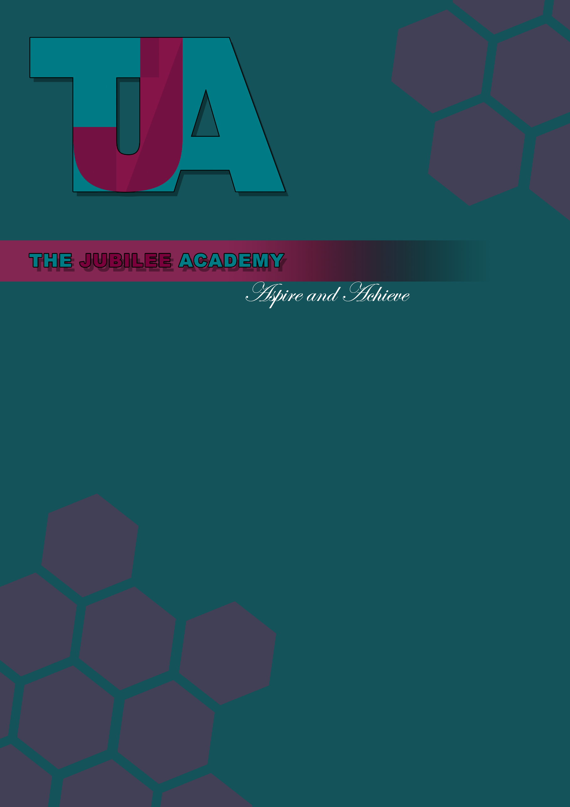
EXAMINATION CONTINGENCY POLICY
2023-24

EXAMINATION CONTINGENCY PLAN

LEGAL
- To meet the requirements of the Ofqual Joint Contingency Plan
- To meet the requirements of the Joint Qualifications Council (JCQ)

MONITORING AND REVIEW
- This policy will be subject to continuous monitoring, refinement and audit by Exams Manager who is a member of SLT

- The Exams Manager will undertake a formal annual review of this policy for the purpose of monitoring by no later than one year from the date shown below, or earlier if significant changes to the systems and arrangements take place, or if legislation, regulatory requirements or best practice guidelines so require.

- In the event of Covid-19 restrictions being put in place, the school will follow government guidelines and implement the appropriate contingency plan in line with the Covid-19 risk assessment.

- The next official date for review is September 2024

CONTENTS
Aims of the Exam Contingency Plan 4
Communications 5
- Disruption of teaching time – centres are closed for an extended period 6
- Disruption in the distribution of examination papers 6
- Candidates unable to take examinations because of a crisis - centres remain Open 6
- Centres are unable to open as normal during the examination period 7
- Examinations staff absence 7
- Disruption to the transportation of completed examination scripts 7
- Assessment evidence is not available to be marked 7
- Disruption to the scanning process 7
- Markers unable to mark examination scripts according to marking schedules 8
- Difficulty in meeting planned schedule or unable, to issue results 8
- Awarding organisations unable to issue accurate results 8
- Centres are unable to distribute results as normal 8
Summary of School responsibilities in the event of disruption to examinations 9
Useful links and information 10

AIMS OF THE CONTINGENCY PLAN
The Examination Contingency Plan is designed to ensure a consistent and effective response in the event of major disruption to the examination system at The Jubilee Academy affecting candidates across several awarding organisations.

All awarding organisations are required to have their own well-established contingency plans in place to respond to such disruptions. This Examinations Contingency Plan takes into account these processes and procedures and is designed to complement them, not replace them. This also applies to all other qualifications at The Jubilee Academy

The plan will be implemented in the event of major disruption to the system, such as widespread illness, travel disruption, bad weather or power failures. Any actions taken will be subject to the advice of the official agencies dealing with the specific circumstances being faced, for example the police, Environment Agency or Health Protection Agency.

Implementing the plan will safeguard the interests of candidates while maintaining the integrity of the examination system and safeguarding qualification standards.

The priority when implementing contingencies will be to maintain three principles:

delivering assessments to published timetables

delivering results to published timetables

complying with regulatory requirements in relation to assessment, marking and standards.

If the usual contingencies are no longer sufficient to maintain these outcomes, the Senior Leadership Team will meet to agree the additional actions required.

COMMUNICATIONS
In the event of local disruption, communication to teachers and students will take place through the usual channels via text and on the school website.

In the event of major disruption, details of specific contingencies agreed across Organisations involved in the examinations process will be confirmed on the Ofqual website and proactively communicated to relevant stakeholders.

This includes communications between the organisations involved in the response and communications to stakeholders such as centres, candidates, parents or carers and the public.

www.ofqual.gov.uk/

The organisations involved in this Joint Contingency Plan are committed to:

- sharing timely and accurate information as required to meet the aims of the plan

- communicating with stakeholders so they are aware of disruption to the exams, the contingency measures being implemented and any actions required of them as a result

- ensuring that any messages to the public are clear and accurate.

- DISRUPTION OF TEACHING TIME – SCHOOL CLOSED FOR AN EXTENDED PERIOD

If The Jubilee Academy is closed or candidates are unable to attend for an extended period during normal teaching or study supported time, interrupting the provision of normal teaching and learning. It is the responsibility of the School to prepare students, as usual, for examinations.

  - The School should plan to facilitate teaching and learning by an alternative method or alternative location.
  - The School may offer candidates an opportunity to sit any examinations missed at the next available series

Guidance on emergency planning, with advice on severe weather, is available on the Department for Education website:
https://www.gov.uk/guidance/emergencies-and-severe-weather-schools-and-early-years-settings

DISRUPTION IN THE DISTRIBUTION OF EXAMINATION PAPERS

If the distribution of examination papers to centres in advance of Examinations is disrupted:

  - The awarding organisations to source alternative couriers for delivery of hardcopies.
  - The awarding organisations would provide the School with electronic access to examination papers via a secure external network. Awarding organisations would fax examination papers to centres if electronic transfer is not possible. The Exams Manager must ensure that copies are received, made and stored under secure conditions.

- CANDIDATES UNABLE TO TAKE EXAMINATIONS BECAUSE OF A CRISIS

This contingency applies if The Jubilee Academy becomes closed due to extreme issues on the school site e.g. Fire, Flood.

  - The School can liaise with candidates to identify whether the examination can be sat at an alternative venue in agreement with the relevant awarding organisations. JCQ guidance on alternative site arrangements can be accessed through the JCQ website:
https://www.jcq.org.uk/exams-office/ice---instructions-for-conducting-examinations

  - The School can apply to awarding organisations for special consideration for candidates where they have met the minimum requirements. Candidates are only eligible for special consideration if they have been fully prepared and have covered the whole course but are affected by adverse circumstances beyond their control. JCQ guidance on special consideration can be accessed through the JCQ website: www.jcq.org.uk/exams-office/access-arrangements-and-specialconsideration/regulations- andguidance

CENTRES ARE UNABLE TO OPEN AS NORMAL DURING THE EXAMINATION PERIOD

If The Jubilee Academy is unable to open as normal for scheduled examinations, it must inform each awarding organisation with which examinations are due to be taken as soon as is possible.

The responsibility for deciding whether it is safe for the School to open lies with the Head of Centre. The Head of Centre is responsible for taking advice, or following instructions from relevant local or national agencies in deciding whether they are able to open.

  - The School should open for examinations and examination candidates only if possible
  - The School should use alternative venues in agreement with relevant awarding organisations (e.g. share facilities with other centres or use other public building, if possible). An agreement has been made with Whitmore High School for The School to use their site as an alternative venue.
  - The School may offer candidates an opportunity to sit any examinations missed at the next available series
  - The School can apply to awarding organisations for special consideration for candidates where they have met the minimum requirements (see item 3)

- EXAMINATION STAFF ABSENCE

In the event that key Examination staff are absent, the hieracy of responbility is as follows:

  - Examinations Manager
  - Head of School

DISRUPTION TO THE TRANSPORTATION OF COMPLETED EXAMINATION SCRIPTS

If there is a delay in normal collection arrangements for completed examination scripts.

  - The School will seek advice from awarding organisations and normal collection agency regarding collection. The School must not to make arrangements for transportation without approval from awarding organisations.
  - The School must ensure secure storage of completed examination scripts until collection.

ASSESSMENT EVIDENCE IS NOT AVAILABLE TO BE MARKED

If due to large scale damage to or destruction of completed examination scripts/assessment evidence before it can be marked.

  - The awarding organisations should generate candidate marks for affected assessments based on other appropriate evidence of candidate achievement as defined by the awarding organisations in consultation with the regulators.
  - The candidates should retake affected assessment at subsequent assessment window.

DISRUPTION TO THE SCANNING PROCESS
- WHERE COMPLETED EXAMINATION SCRIPTS ARE BEING SCANNED IN PREPARATION FOR ONSCREEN MARKING

If the examination boards scanning process is disrupted, resulting in a risk to the delivery of results by scheduled dates.

  - The awarding organisations should implement their existing contingency plans for disruption to onscreen marking process

  - The awarding organisations should revert to traditional form of marking
  - The awarding organisations should recruit, train or re-standardise qualified new markers.

MARKERS UNABLE TO MARK EXAMINATION SCRIPTS ACCORDING TO MARKING SCHEDULES

If the examination board markers are unable to mark examination scripts resulting in a risk to the delivery of results by scheduled dates.

The awarding organisations should re-allocate scripts to available markers

The awarding organisations to recruit, train or re-standardise qualified new markers and prioritisation of marking to be based on results dates.

DIFFICULTY IN MEETING PLANNED SCHEDULE OR UNABLE, TO ISSUE RESULTS

Inability of awarding organisations (including the case of a single awarding organisation) to either meet planned schedule for issue of results, or to issue results as planned due to a systems failure. If the awarding organisation(s) face delay in meeting the planned schedule for issuing results:

The awarding body should establish priorities for processing results, implement existing contingency plans for disruption to the schedule for issuing results.

If awarding organisation(s) face difficulty in issuing results as planned due to a systems failure: in consultation with regulators, assess the level of disruption and consider alternative options for issuing results dependent upon the nature of the particular systems failure, the awarding organisations and regulators to liaise with relevant organisations regarding process of candidate progression to further and higher education.

AWARDING ORGANISATIONS UNABLE TO ISSUE ACCURATE RESULTS

Due to system error/failure or attack on systems means significant numbers of results cannot be validated as accurate or are issued and found to be inaccurate.

The candidates, School and stakeholders will be informed of any incorrect results

The awarding organisations will re-validation results

The awarding organisations to re-issue results, via alternative format if necessary.

CENTRES ARE UNABLE TO DISTRIBUTE RESULTS AS NORMAL

If the School is unable to access or manage the distribution of results to candidates, or to facilitate post results services.

The School should contact the awarding organisations about alternative options:

The School will make arrangements to access its results at an alternative site.

The School will make arrangements to coordinate access to post results services from an alternative site.

The School will share facilities with other centres where possible.

SUMMARY OF SCHOOL RESPONSIBILITIES IN THE EVENT OF DISRUPTION TO EXAMINATIONS
  - Preparing plans for any disruption to exams as part of centres’ general emergency planning.

  - Preparing candidates for examinations.

  - Ensuring examinations and assessments are taken under the conditions prescribed by awarding organisations.

  - Ensuring, where relevant, that assessment materials and candidate work are stored under secure conditions.

  - Deciding whether the centre can open for examinations as scheduled and informing relevant awarding organisations if the centre is unable to open.

  - Exploring the opportunities for alternative arrangements if the centre cannot open for examinations and agreeing such arrangements with the awarding organisations.

  - Assessing and liaising with awarding organisations in the event of disruption to the transportation of papers.

USEFUL LINKS AND INFORMATION

JCQ | http://www.jcq.org.uk
Ofqual | http://www.ofqual.gov.uk
AQA | http://www.aqa.org.uk/
Edexcel | http://qualifications.pearson.com/en/home.html
OCR | http://www.orc.org.uk
WJEC | http://www.wjec.co.uk
CIE | http://www.cie.org.uk
IFS | http://www.ifslearning.ac.uk
DfE | http://www.education.gov.uk
DfE – Exams | https://www.gov.uk/guidance/exams-administration-information-for-exam-centres
EDI | http://www.ediplc.com
UCAS  JCQ – Special Co | http://www.ucas.ac.uk  nsiderations Guidance http://www.jcq.org.uk/exams-office/access-arrangements-and-

specialconsideration/regulations-and-guidance/a-guide-to-the-special-considerationprocess JCQ – Instructions for conducting examinations http://www.jcq.org.uk/exams-office/ice---instructions-for-
conducting-examinations
DfE guidance on dealing with disruption to teaching and learning http://www.education.gov.uk/schools/adminandfinance/emergencyplanning/a0069425/adviceon- severe-weather

