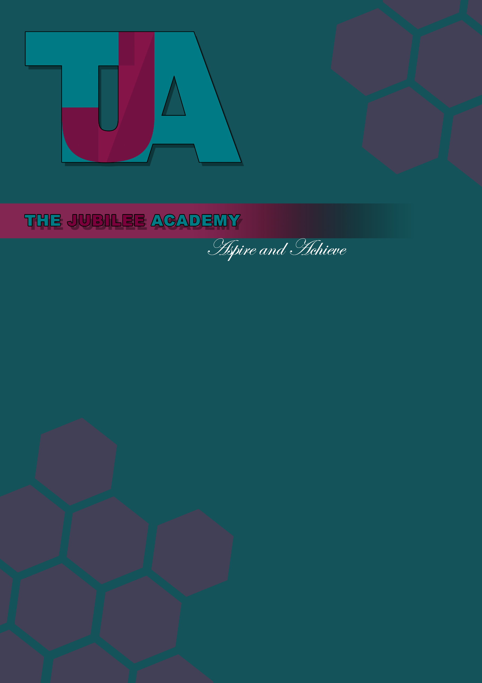

Title: Information to Parents/Prospective Parents Policy

Date Approved: July 2013

Date Last Reviewed: July 2023

Status: Statutory

Delegation: Head of School

Responsibility: PA, Marketing and Admissions Manager

Review Frequency: Annually

Policy Locations: Website/Staff Shared Drive/Hard Copy

Next Review Date: July 2024



Policy Essential Information

Information to Parents/Prospective Parents Policy
Statement of intent
The Schools Information Regulations 2012 now require schools to publish certain key information online.
They must make the following information available:
- Their pupil premium allocation, its use and impact on attainment
- Details of curriculum provision, content and approach, by academic year and by subject
- Admission arrangements
- The school's policy in relation to behaviour, charging, and special educational needs and disability provision
- Links to Ofsted reports and to the DfE’s achievement and attainment performance data, as well as details of the school’s latest Key Stage 2 and 4 attainment and progress measures

Statement of the school’s ethos and values
The Jubilee Academy’s vision is to ensure that every student fulfils their promise, develops their potential and reaches or exceeds age related expectations. Our students will leave us being fully equipped and prepared to grasp every future opportunity in their lives.

The Governing Body together with the staff, are ambitious for the school and its students and intend to ensure that every young person is as aspirational for their own future as we are. Each dimension of school life and aspect of the curriculum, together with its supporting organisational structures and systems, is designed to secure this vision.

Our staff and governors will know that how we feel affects how we learn and will hold this as central to the school ethos. Our approach will be characterised by a deep desire to offer new opportunities to students who may have experienced previous difficulties.

The Jubilee Academy values high standards, maximum effort and full commitment to learning and progress. We prize a welcoming, cheerful, caring, safe and disciplined environment where learning can be outstanding for everyone.

We aim to provide the highest standards of educational provision for all of our students. Our vision statement is ‘Aspire and Achieve’ and this allows us to tailor every aspect of school life to ensure each student fulfils their potential. We want every student to enjoy coming to school and to achieve their full educational potential. We understand that students get one opportunity at secondary school and it is essential to us that our students get the best educational opportunities possible.

These values will be demonstrated through a ‘tough caring’ approach characterised by high expectations of all members of the school community.

The partnership between parents/carers and school is a fundamental ingredient in ensuring the success of each individual student. By working together we will ensure that your child achieves an outstanding education.

With our partners and networks the school will achieve more than was ever thought possible for, and with, its community.

Curriculum provision, content and approach
The website provides comprehensive information about:
- The curriculum:
- The content of the school's curriculum for each subject and details of how to obtain additional information about the curriculum;
- In relation to KS4 a list of the courses provided that lead to a GCSE qualification and details about other courses offered at KS4 and the qualifications that may be acquired.
- Additional specific interventions;
- The referral and transition procedure;
- Safeguarding arrangements; and
- Costs.

Our charging and remissions policy is also available on the website.

Policies on behaviour, SEND and disability provision.
Our policies on behaviour, SEND and disability provision are published on our website.

A guide for parents on school behaviour and exclusion can be found:
School exclusions: guide for parents - GOV.UK (www.gov.uk)

Ofsted
In line with the regulations, we will provide information as to where and by what means parents/carers may access the school’s Ofsted reports.

Monitoring, evaluation and review
This effectiveness of this policy will be regularly monitored and reviewed.

