11th February 2022

Dear Parent/Carer,
Summer exams for GCSEs, AS and A levels will be taking place in 2022 for the first time since the COVID-19 pandemic began. Ofqual and the Department for Education recognise the difficulties students may have faced during the pandemic, and changes have been made to this year’s arrangements to help students.
An unprecedented package of support has been put in place for students. Advance information will help them focus their revision. Exam boards have provided advance information for exams in most subjects. Students will have a choice of topics or content in some other GCSE subjects. Exam boards will also provide a formulae sheet and an updated equation sheet that students will have in their GCSE maths, physics and combined science exams.
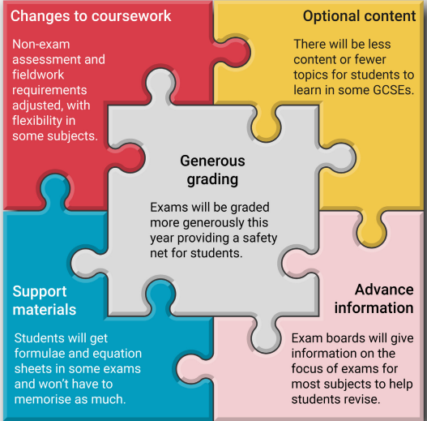
This advance information will also help teachers manage revision time in the lead-up to exams. In addition, more generous grading will provide a safety net for students.

The government intends that exams will go ahead in summer 2022, with some changes to exams and non-exam assessments:
- exams will be graded more generously this year – providing a safety net for students
- advance information will help students to focus their revision
- exam boards have provided advance information for exams in most subjects
- students will have a choice of topics or content in some other GCSE subjects
- exam boards will provide a formulae sheet and an updated equation sheet that students will have in their GCSE maths, physics and combined science exams

Advance information might look different for different subjects because of how they are structured and assessed, but as far as possible the exam boards have made sure the approaches within a subject are the same.
Exam boards have published specific information about the changes for each qualification they offer, you should check their websites for more information:
- AQA
- OCR
- Pearson Edexcel
- WJEC Eduqas

GCSEs
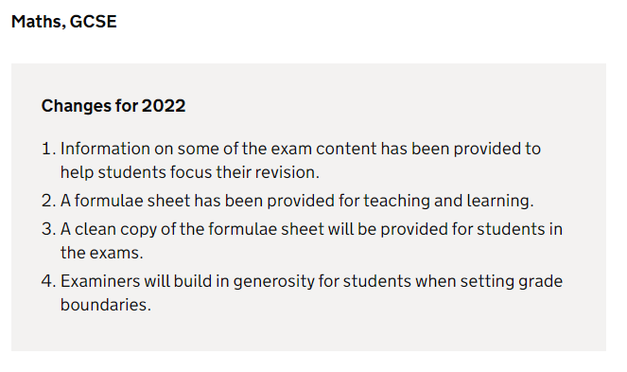
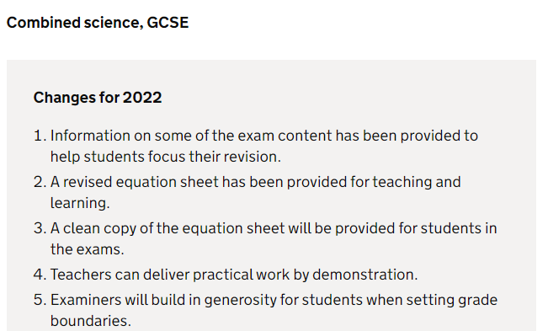
Where we list changes for subjects in 2022, we only list what has changed, not what is remaining the same.
Science Further Information Maths Further Information

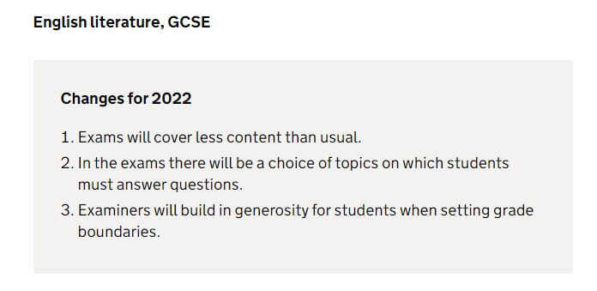
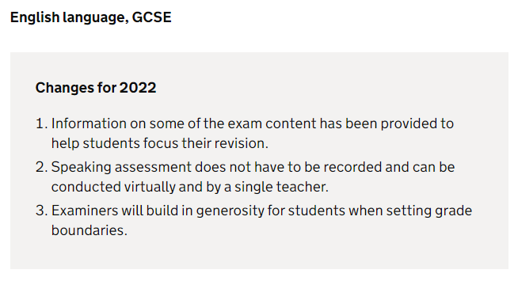
English Language Further Information English Literature Further Information

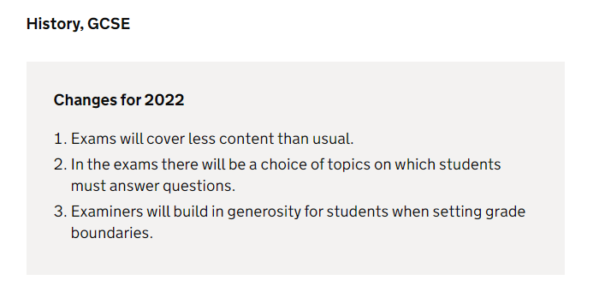
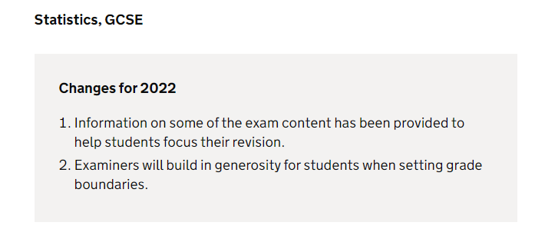

History Further information Statistics Further Information

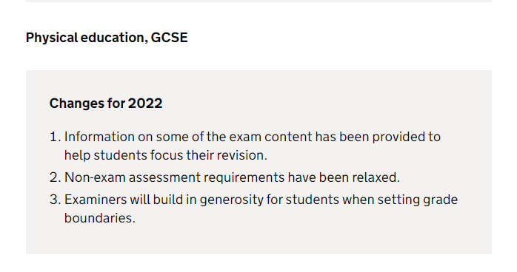
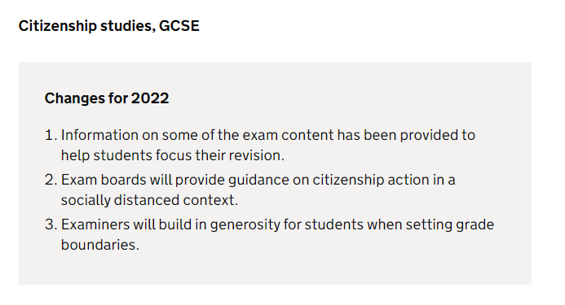

PE Further Information
Citizenship Further Information
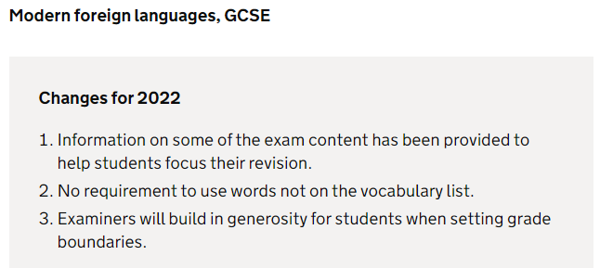

Spanish Further Information
French Further Information
Arabic Further Information
Urdu Further information

Advanced information notices for all subjects at GCSE except GCSE English literature
and history, that have been released by the exam boards can be found on the
school website under the Exams Tab.

Teachers will discuss this with your child and the notices can be used to help your child focus their revision time.

Vocational and technical qualifications 2022
Results for vocational and technical qualifications in 2022 will be based on the outcome of exams and assessments. Awarding organisations will be allowed to make adaptations to assessments and qualifications, where they need to, due to the pandemic.
Adaptations for Cambridge Nationals and Cambridge Technicals during 2021/22
Adaptations for BTEC Tech Awards guidance 2021/22
Contingency plans in case exams cannot go ahead as planned
The government intends that exam will go ahead in 2022. If exams cannot go ahead as planned, students will receive grades determined by their teachers, using teacher-assessed grades (TAGs) similar to those used in summer 2021. TAGs are based on teachers’ assessment of their students’ work.
Further Resources and guidance regarding the exams can be found on the school website at: https://www.thejubileeacademy.org.uk/exams

For all other concerns, please email: info@thejubileeacademy.org.uk

Thank you for your continued support.
Yours sincerely,



Dr M Jarrett
Head Teacher

