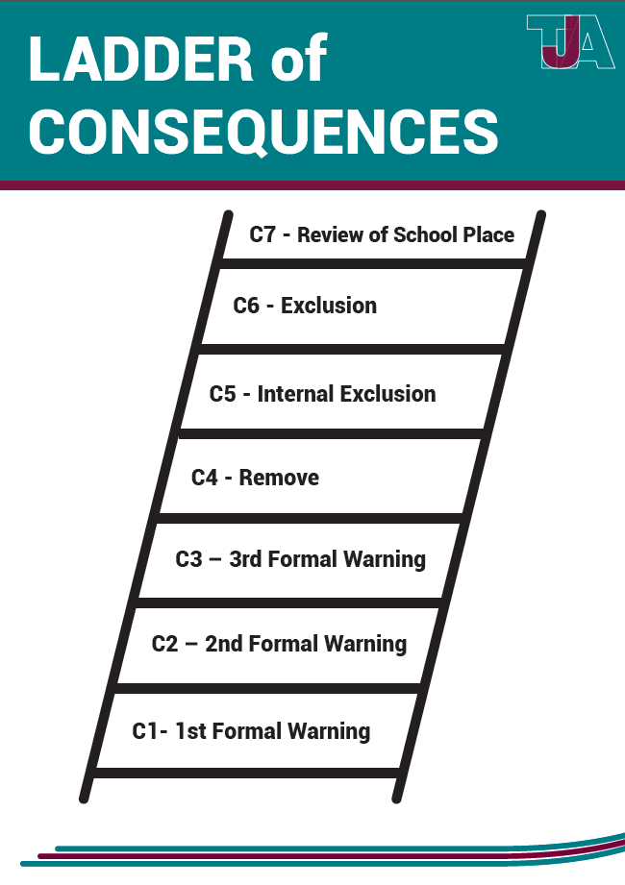
Suspension
Plus a 20 minute detention

Suspension

