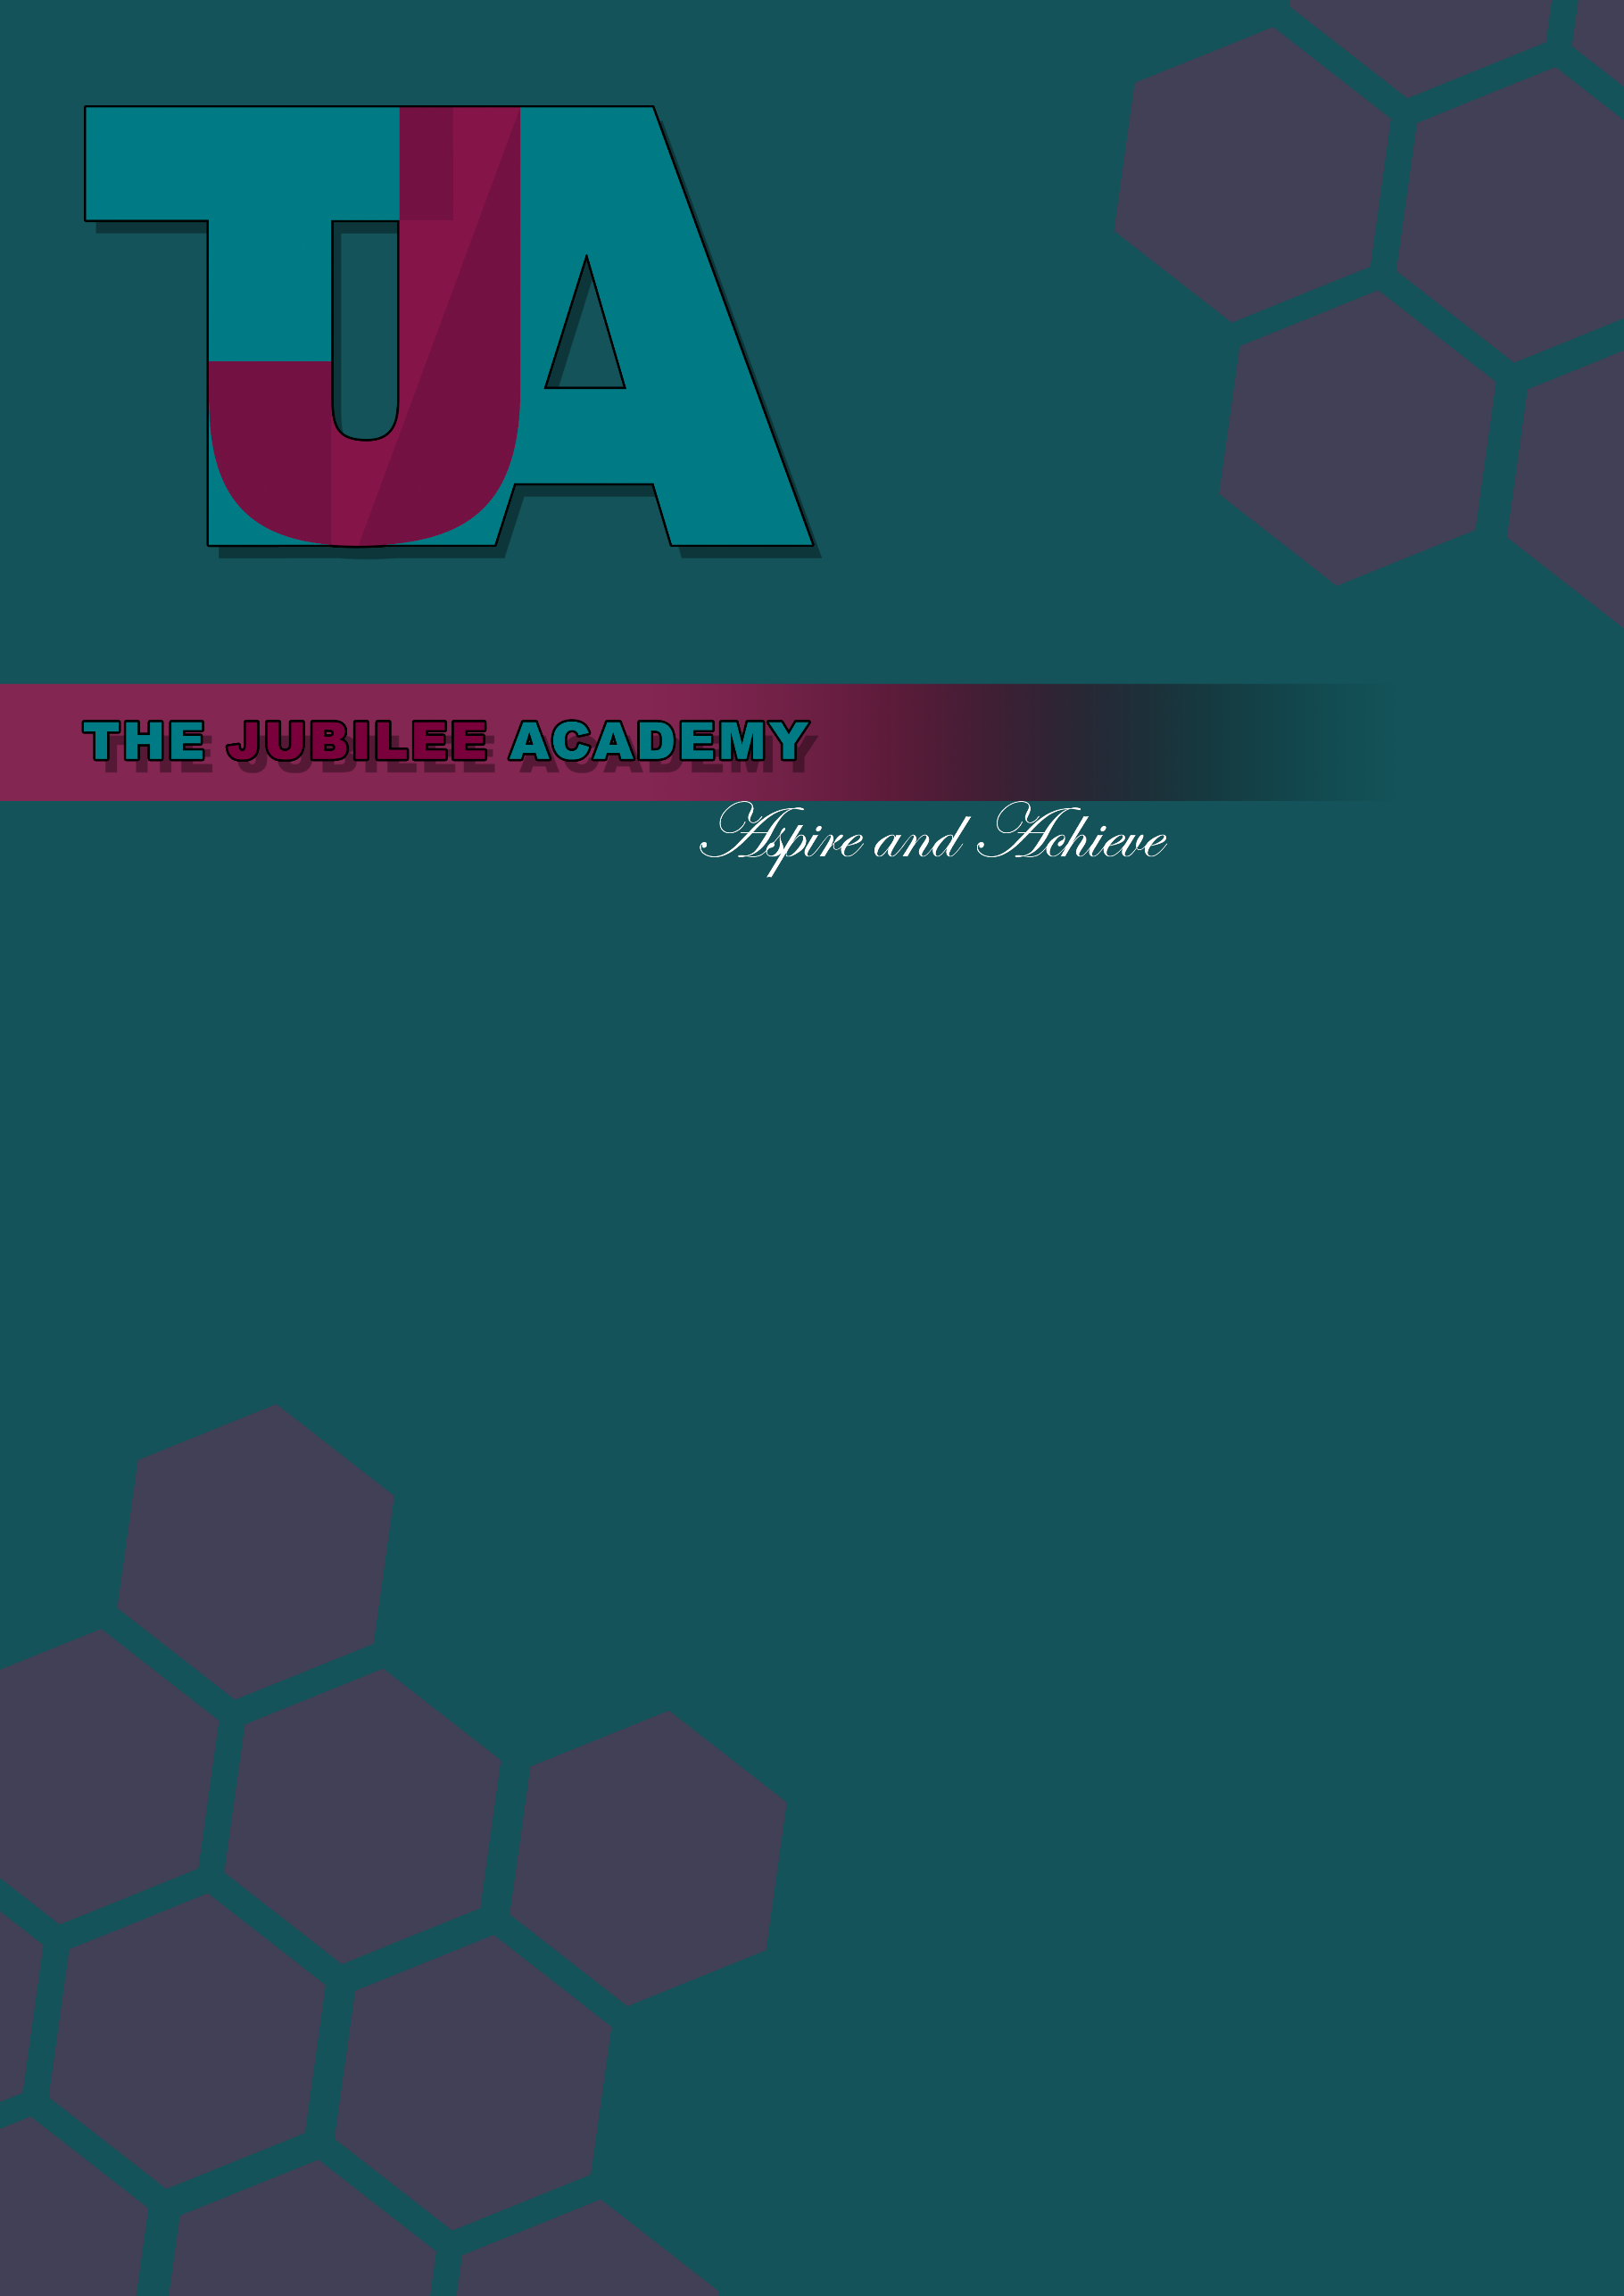
Title: Freedom of Information Policy and Publication Scheme

Date Approved: July 2013

Date Last Reviewed: MARCH 2022

Status: Statutory

Delegation: Head of School

Responsibility: SBM H&S

Review Frequency: Biannually

Policy Locations: Website/Staff Shared Drive/Hard Copy

Next Review Date: March 2024

Policy Locations: Website/Staff Shared Drive/Hard Copy







Freedom of Information Policy

Introduction

The Freedom of Information Act 2000 gives individuals the right to access official information from public bodies. Under the Act, any person has a legal right to ask for access to information held by the school. They are entitled to be told whether the school holds the information, and to receive a copy, subject to certain exemptions. While the Act assumes openness, it recognises that certain information is sensitive. There are exemptions to protect this information. Full details on how requests can be made are set out in section 1 of this policy.

Public Authorities should be clear and proactive about the information they will make public. For this reason, a publication scheme is available and can be found at section 2 of this policy.
This policy does not form part of any individual’s terms and conditions of employment with the School and is not intended to have contractual effect.

Section 1 – Freedom of Information Requests

This policy should be used in conjunction with the school’s Data Protection Policy.
Requests under Freedom of Information should be made to the SBM via data@thejubileeacademy.onmicrosoft.com. However, the request can be addressed to anyone in the School. All staff need to be aware of the process for dealing with requests.
Requests for information that are not data protection or environmental information requests will be covered by the Freedom of Information Act.

Data Protection enquiries (or Subject Access Requests/SARs) are requests where the enquirer asks to see what personal information the school holds about the enquirer. If the enquiry is a Data Protection request, the School’s Data Protection Policy should be followed.
Environmental Information Regulations enquiries are those which relate to air, water, land, natural sites, built environment, flora and fauna, health, and any decisions and activities affecting any of these. These could, therefore, include enquiries about recycling, phone masts, school playing fields, car parking etc. If the enquiry is about environmental information, follow the guidance on the Department for Environment, Food and Rural Affairs (DEFRA) website.
Freedom of Information requests must be made in writing, (including email), and should include the enquirer’s name, correspondence address (email addresses are allowed), and state what information they require. There must be enough information in the request to be able to identify and locate the information. If this information is covered by one of the other pieces of legislation (as referred to above), they will be dealt with under the relevant policy/procedure related to that request.
If the request is ambiguous and/or the School require further information in order to deal with your request, the School will request this further information directly from the individual making the request. Please note that the School do not have to deal with the request until the further information is received. Therefore, the time limit starts from the date that the School receives all information required in order to deal with the request.
The requester does not have to mention the Act, nor do they have to say why they want the information. There is a duty to respond to all requests, telling the enquirer whether or not the information is held, and supplying any information that is held, except where exemptions apply. There is a time limit of 20 school days (i.e. excluding school holidays) for responding to the request.

Information

Provided all requirements are met for a valid request to be made, the School will provide the information that it holds (unless an exemption applies).
Holding information means information relating to the business of the school:
- That the school has created; or
- That the school has received from another body or person; or
- Held by another body on the school’s behalf.
Information means both hard copy and digital information, including email.
If the information is held by another public authority, such as the Local Authority, first check with them they hold it, then transfer the request to them. If this applies, the School will notify the enquirer that they do not hold the information and to whom they have transferred the request. The School will continue to answer any parts of the enquiry in respect of information it does hold.
When the School does not hold the information, it has no duty to create or acquire it just to answer the enquiry; although a reasonable search will be made before confirming whether the School has the information requested.
If the information requested is already in the public domain, for instance, through the Publication Scheme or on the School’s website, the School will direct the enquirer to the information and explain how to access it.
The requester has the right to be told if the information requested is held by the School (subject to any of the exemptions). This obligation is known as the school’s duty to confirm or deny that it holds the information. However, the school does not have to confirm or deny if:
- The exemption is an absolute exemption; or
- In the case of qualified exemptions, confirming or denying would itself disclose exempted information.

Vexatious Requests

There is no obligation on the School to comply with vexatious requests. A vexatious request is one which is designed to cause inconvenience, harassment or expense rather than to obtain information, and would require a substantial diversion of resources or would otherwise undermine the work of the school. However, this does not provide an excuse for bad records management.
In addition, the School do not have to comply with repeated identical or substantially similar requests from the same applicant unless a reasonable interval has elapsed between requests.

Fees

The School may charge the requester a fee for providing the requested information. This will be dependent on whether the staffing costs in complying with the request exceeds the threshold. The threshold is currently £450 with staff costs calculated at a fixed rate of £25 per hour (therefore 18 hours’ work is required before the threshold is reached).
If a request would cost less than the threshold, then the school can only charge for the cost of informing the applicant whether the information is held, and communicating the information to the applicant (e.g. photocopying, printing and postage costs).
When calculating costs/threshold, the School can take account of the staff costs/time in determining whether the information is held by the School, locating and retrieving the information, and extracting the information from other documents. The School will not take account of the costs involved with considering whether information is exempt under the Act.
If a request would cost more than the appropriate limit, (£450) the school can turn the request down, answer and charge a fee or answer and waive the fee.
If the School are going to charge they will send the enquirer a fees notice. The School do not have to comply with the request until the fee has been paid. More details on fees can be found on the ICO website.
If planning to turn down a request for cost reasons, or charge a high fee, you should contact the applicant in advance to discuss whether they would prefer the scope of the request to be modified so that, for example, it would cost less than the appropriate limit.
Where two or more requests are made to the School by different people who appear to be acting together or as part of a campaign the estimated cost of complying with any of the requests may be taken to be the estimated total cost of complying with them all.

Time Limits

Compliance with a request must be prompt and within the time limit of 20 school days (this does not include the school holidays or weekends) or 60 working days if this is shorter. Failure to comply could result in a complaint by the requester to the Information Commissioner’s Office. The response time starts counting as the first day from the next working day after the request is received (so if a request was received on Monday 6th October the time limit would start from the next working day, the 7th October).
Where the School has asked the enquirer for more information to enable it to answer, the 20 school days start time begins when this further information has been received.
If some information is exempt this will be detailed in the School’s response.
If a qualified exemption applies and the School need more time to consider the public interest test, the School will reply in 20 school days stating that an exemption applies but include an estimate of the date by which a decision on the public interest test will be made. This should be within a “reasonable” time.
Where the School has notified the enquirer that a charge is to be made, the time period stops until payment is received.
Third Party Data
Consultation of third parties may be required if their interests could be affected by release of the information requested, and any such consultation may influence the decision.
Consultation will be necessary where:
- Disclosure of information may affect the legal rights of a third party, such as the right to have certain information treated in confidence or rights under Article 8 of the European Convention on Human Rights;
- The views of the third party may assist the School to determine if information is exempt from disclosure; or
- The views of the third party may assist the School to determine the public interest test.

Personal information requested by third parties is also exempt under this policy where release of that information would breach the Data Protection Act. If a request is made for a document (e.g. Governing Body minutes) which contains personal information whose release to a third party would breach the Data Protection Act, the document may be issued by blanking out the relevant personal information as set out in the redaction procedure.
Exemptions
The presumption of the Freedom of Information Act is that the School will disclose information unless the Act provides a specific reason to withhold it. The Act recognises the need to preserve confidentiality and protect sensitive material in certain circumstances.
The School may refuse all/part of a request, if one of the following applies: -
- There is an exemption to disclosure within the act;
- The information sought is not held;
- The request is considered vexatious or repeated; or
- The cost of compliance exceeds the threshold.

A series of exemptions are set out in the Act which allow the withholding of information in relation to an enquiry. Some are specialised in their application (such as national security) and would not usually be relevant to schools.
There are two general categories of exemptions:-
- Absolute: where there is no requirement to confirm or deny that the information is held, disclose the information or consider the public interest; and
- Qualified: where, even if an exemption applies, there is a duty to consider the public interest in disclosing information.

Absolute Exemptions
There are eight absolute exemptions set out in the Act. However, the following are the only absolute exemptions which will apply to the School: -
- Information accessible to the enquirer by other means (for example by way of the School’s Publication Scheme);
- National Security/Court Records;
- Personal information (i.e. information which would be covered by the Data Protection Act);
- Information provided in confidence.

If an absolute exemption exists, it means that disclosure is not required by the Act. However, a decision could be taken to ignore the exemption and release the information taking into account all the facts of the case if it is felt necessary to do so.
Qualified Exemptions
If one of the below exemptions apply (i.e. a qualified disclosure), there is also a duty to consider the public interest in confirming or denying that the information exists and in disclosing information.
The qualified exemptions under the Act which would be applicable to the School are: -
- Information requested is intended for future publication (and it is reasonable in all the circumstances for the requester to wait until such time that the information is actually published);
- Reasons of National Security;
- Government/International Relations;
- Release of the information is likely to prejudice any actual or potential legal action or formal investigation involving the School;
- Law enforcement (i.e. if disclosure would prejudice the prevention or detection of crime, the prosecution of offenders or the administration of justice);
- Release of the information would prejudice the ability of the School to carry out an effective audit of its accounts, resources and functions;
- For Health and Safety purposes;
- Information requested is Environmental information;
- Information requested is subject to Legal professional privilege; and
- For Commercial Interest reasons.

Where the potential exemption is a qualified exemption, the School will consider the public interest test to identify if the public interest in applying the exemption outweighs the public interest in disclosing it.
In all cases, before writing to the enquirer, the person given responsibility by the School for dealing with the request will need to ensure that the case has been properly considered, and that the reasons for refusal, or public interest test refusal, are sound.
Refusal
If it is decided to refuse a request, the School will send a refusals notice, which must contain:
- The fact that the responsible person cannot provide the information asked for;
- Which exemption(s) apply;
- Why the exemption(s) apply to this enquiry (if it is not self-evident);
- Reasons for refusal; and
- The School’s complaints procedure.

For monitoring purposes and in case of an appeal against a decision not to release the information or an investigation by the Information Commissioner, the responsible person must keep a record of all enquiries where all or part of the requested information is withheld and exemptions are claimed. The record must include the reasons for the decision to withhold the information.

Freedom of Information
Guide to information available from The Jubilee Academy under the publication scheme

Information to be published | How the information can be obtained | Charge
Who we are and what we do  (Organisational information, structures, locations and contacts)  This will be current information only. | Hard copy and/or website | Upon request
Academy Funding Agreement – a link to the document on the  Department for Education’s website | Hard copy and/or website | Upon request
Academy Order (if applicable) | N/A | N/A
School staff and structure – names of key personnel | Hard copy and/or website | Upon request
Governing body – names and contact details of the governors and the basis of their appointment | Hard copy and/or website | Upon request
School session times, term dates and holidays | Hard copy and/or website | Upon request
Location and contact information – address, telephone number and website. | Hard copy and/or website | Upon request
Contact details for the Headteacher and Governing Body | Hard copy and/or website | Upon request
School session times and term dates | Hard copy and/or website | Upon request

Information to be published | How the information can be obtained | Charge
What we spend and how we spend it  (financial information relating to projected and actual income and expenditure, procurement, contracts and financial audit)  This should be a minimum of current and the previous two years financial years (accounts that have been filed with the Charity Commission and Companies House). | Hard copy and/or website | Upon request
Annual Budget plan and financial statements | Hard copy and/or website | Upon request
Capital funding – details of capital funding allocated to the school along with information on related building projects and other capital projects. | Hard copy and/or website | Upon request
Additional funding – Income generation schemes and other sources of funding. | Hard copy and/or website | Upon request
Procurement and contracts – details of procedures used for the acquisition of goods and services. Details of contracts that have gone through a formal tendering process. | Hard copy and/or website | Upon request
Staffing structure | Hard copy and/or website | Upon request
Pay policy – a statement of the Academy’s policy on procedures regarding teachers’ pay | Hard copy and/or website | Upon request
Governors’ allowances – Details of allowances and expenses that can be claimed or incurred. | Hard copy and/or website | Upon request

Information to be published | How the information can be obtained | Charge
What our priorities are and how we are doing.  (Strategies and plans, performance indicators, audits, inspections and reviews)  Current information should be published. | Hard copy and/or website | Upon request
School profile  - Government supplied performance data  - OFSTED report – summary and full report | Hard copy and/or website | Upon request
Performance management information | Hard copy and/or website | Upon request
Academy’s future plans – any major proposals on safeguarding and promoting the welfare of children. | Hard copy and/or website | Upon request
Child protection – policies and procedures on safeguarding and promoting the welfare of children. | Hard copy and/or website | Upon request
How we make decisions  (Decision making processes and records of decisions)  Current and previous three years as a minimum | Hard copy and/or website | Upon request
Admissions policy – arrangements and procedures and right of appeal – include information on application numbers and number of successful applicants by each oversubscription criteria. | Hard copy and/or website | Upon request
Governing body meeting agendas, papers and minutes – information that is properly considered to be private should be excluded. | Hard copy and/or website | Upon request

Information to be published | How the information can be obtained | Charge
Our policies and procedures  (Current written protocols, policies and procedures for delivering our services and responsibilities)  Current information only | Hard copy and/or website | Upon request
School policies including:  - Charging and remissions policy  - Health and safety  - Complaints procedure  - Staff conduct policy  - Discipline and grievance policies  - Pay policy  - Staffing structure and implementation plan  - Information request handling policy  - Staff recruitment policies | Hard copy and/or website | Upon request
Pupil and curriculum policies, including;  - Home-school agreement  - Sex education  - Special education needs  - Accessibility  - Equality  - Collective worship  - Pupil discipline | Hard copy and/or website | Upon request

Records management and personal data policies  - Information security  - Records retention  - Destruction and archive policies  - Data Protection policies | Hard copy and/or website | Upon request
Equality and diversity  (Policies, schemes, statements, procedures and guidelines relating to equal opportunities)  - Policies and procedures for the recruitment of staff- details of vacancies should be included | Hard copy and/or website | Upon request
Charging regimes and policies  This should include details of any statutory charging regimes. Charging policies should include details of charges made for information routinely published. They should clearly state what costs are to be recovered, the basis on which they are made and how they are calculated. | Hard copy and/or website | Upon request

Information to be published | How the information can be obtained | Charge
List and Registers  Currently maintained lists and registers only | Hard copy and/or website; some information may only be available for inspection | Upon request
Curriculum circulars and statutory instruments | Hard copy and/or website; some information may only be available for inspection | Upon request
Disclosure logs | Hard copy and/or website; some information may only be available for inspection | Upon request
Asset register | Hard copy and/or website; some information may only be available for inspection | Upon request
Any information the Academy is currently legally required to hold in publicly available registers | Hard copy and/or website; some information may only be available for inspection | Upon request

Information to be published | How the information can be obtained | Charge
The services we offer  (Information about the services we offer, including leaflets, guidance and newsletters produced for the public and businesses) | Hard copy and/or website; some information may only be available for inspection | Upon request
Out of school clubs | Hard copy and/or website; some information may only be available for inspection | Upon request
School publications | Hard copy and/or website; some information may only be available for inspection | Upon request
Services for which the Academy is entitled to recover a fee, together with those fees | Hard copy and/or website; some information may only be available for inspection | Upon request
Leaflets, booklets and newsletters | Hard copy and/or website; some information may only be available for inspection | Upon request

