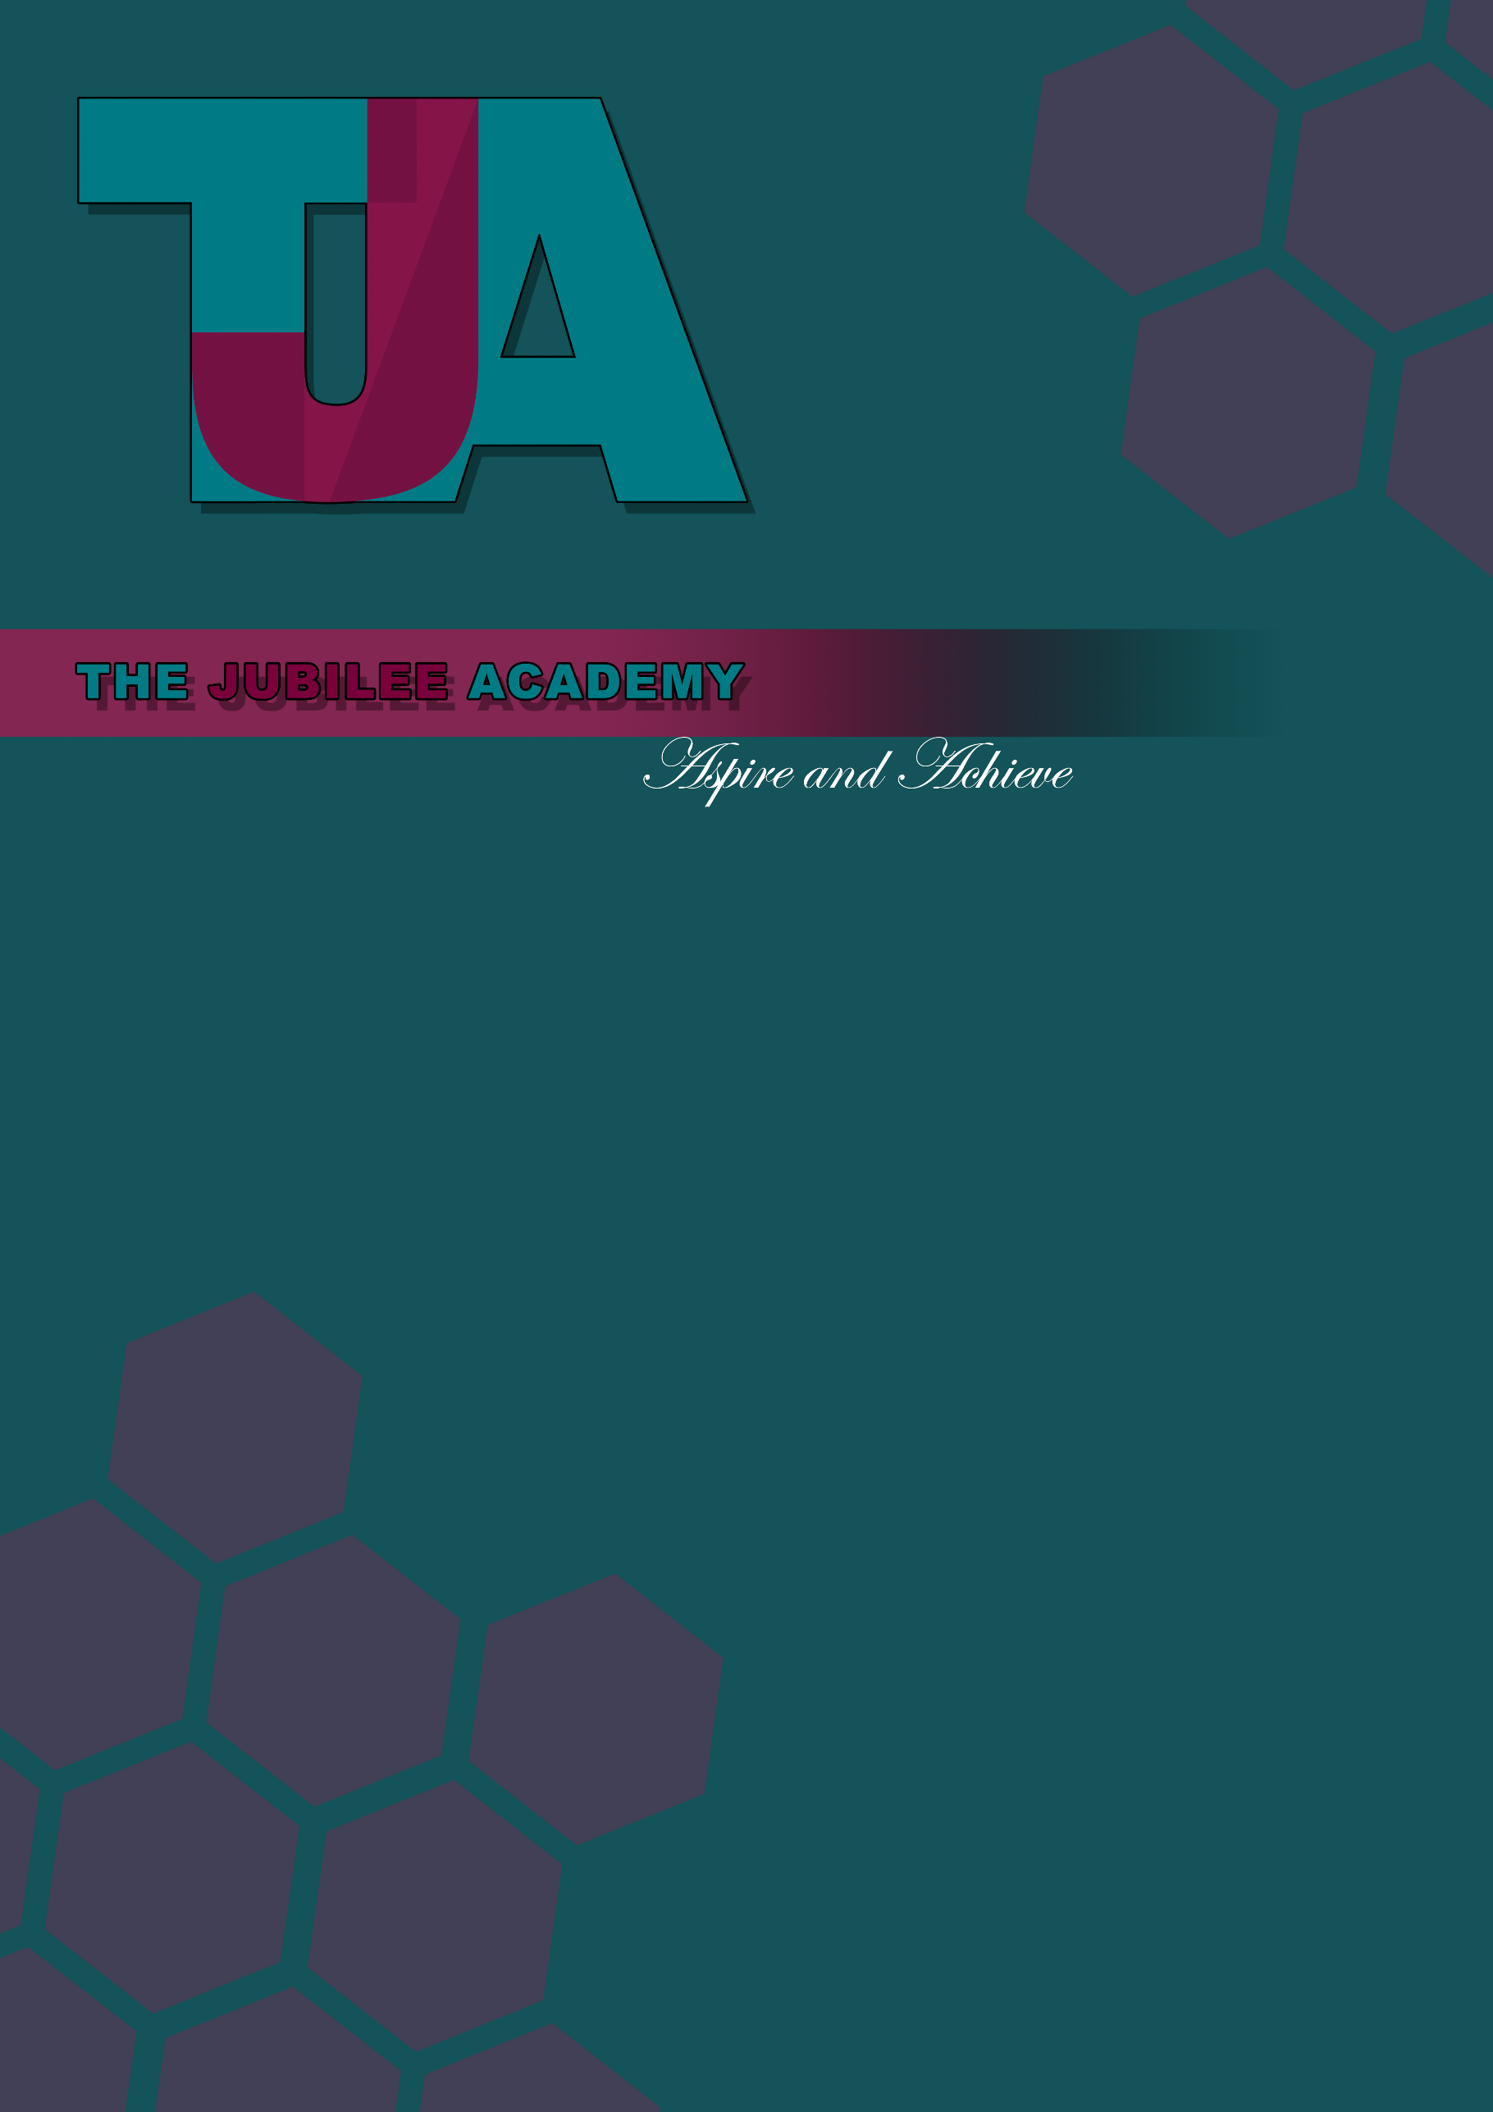
Title: Freedom of Information Policy and Publication Scheme

Date Approved: July 2013

Date Last Reviewed: MARCH 2023

Status: Statutory

Delegation: Head of School

Responsibility: SBM H&S

Review Frequency: Biannually

Policy Locations: Website/Staff Shared Drive/Hard Copy

Next Review Date: March 2024

Policy Locations: Website/Staff Shared Drive/Hard Copy







Freedom of Information Policy

Introduction

The Freedom of Information Act 2000 gives individuals the right to access official information from public bodies. Under the Act, any person has a legal right to ask for access to information held by the school. They are entitled to be told whether the school holds the information, and to receive a copy, subject to certain exemptions. While the Act assumes openness, it recognises that certain information is sensitive. There are exemptions to protect this information. Full details on how requests can be made are set out in section 1 of this policy.

Public Authorities should be clear and proactive about the information they will make public. For this reason, a publication scheme is available and can be found at section 2 of this policy.
This policy does not form part of any individual’s terms and conditions of employment with the School and is not intended to have contractual effect.

This policy should be used in conjunction with the School’s Data Protection Policy.

Section 1 – Freedom of Information Requests

This policy should be used in conjunction with the school’s Data Protection Policy.
Requests under Freedom of Information should be made to the SBM via data@thejubileeacademy.onmicrosoft.com. However, the request can be addressed to anyone in the School. All staff need to be aware of the process for dealing with requests.
Requests for information that are not data protection or environmental information requests will be covered by the Freedom of Information Act.

Data Protection enquiries (or Subject Access Requests/SARs) are requests where the enquirer asks to see what personal information the school holds about the enquirer. If the enquiry is a Data Protection request, the School’s Data Protection Policy should be followed.
Environmental Information Regulations enquiries are those which relate to air, water, land, natural sites, built environment, flora and fauna, health, and any decisions and activities affecting any of these. These could, therefore, include enquiries about recycling, phone masts, school playing fields, car parking etc. If the enquiry is about environmental information, follow the guidance on the Department for Environment, Food and Rural Affairs (DEFRA) website.
Freedom of Information requests must be made in writing, (including email), and should include the enquirer’s name, correspondence address (email addresses are allowed), and state what information they require. There must be enough information in the request to be able to identify and locate the information. If this information is covered by one of the other pieces of legislation (as referred to above), they will be dealt with under the relevant policy/procedure related to that request.
If the request is ambiguous and/or the School require further information in order to deal with your request, the School will request this further information directly from the individual making the request. Please note that the School do not have to deal with the request until the further information is received. Therefore, the time limit starts from the date that the School receives all information required in order to deal with the request.
The requester does not have to mention the Act, nor do they have to say why they want the information. There is a duty to respond to all requests, telling the enquirer whether or not the information is held, and supplying any information that is held, except where exemptions apply. There is a time limit of 20 school days (i.e. excluding school holidays) for responding to the request.

Information

Provided all requirements are met for a valid request to be made, the School will provide the information that it holds (unless an exemption applies).
Holding information means information relating to the business of the school:
- That the school has created; or
- That the school has received from another body or person; or
- Held by another body on the school’s behalf.

Information means both hard copy and digital information, including email.
If the information is held by another public authority, such as the Local Authority, first check with them they hold it, then transfer the request to them. If this applies, the School will notify the enquirer that they do not hold the information and to whom they have transferred the request. The School will continue to answer any parts of the enquiry in respect of information it does hold.
When the School does not hold the information, it has no duty to create or acquire it just to answer the enquiry; although a reasonable search will be made before confirming whether the School has the information requested.
If the information requested is already in the public domain, for instance, through the Publication Scheme or on the School’s website, the School will direct the enquirer to the information and explain how to access it.
The requester has the right to be told if the information requested is held by the School (subject to any of the exemptions). This obligation is known as the school’s duty to confirm or deny that it holds the information. However, the school does not have to confirm or deny if:
- The exemption is an absolute exemption; or
- In the case of qualified exemptions, confirming or denying would itself disclose exempted information.

Vexatious Requests

There is no obligation on the School to comply with vexatious requests. A vexatious request is one which is designed to cause inconvenience, harassment or expense rather than to obtain information, and would require a substantial diversion of resources or would otherwise undermine the work of the school. However, this does not provide an excuse for bad records management.
In addition, the School do not have to comply with repeated identical or substantially similar requests from the same applicant unless a reasonable interval has elapsed between requests.

Fees

The School may charge the requester a fee for providing the requested information. This will be dependent on whether the staffing costs in complying with the request exceeds the threshold. The threshold is currently £450 with staff costs calculated at a fixed rate of £25 per hour (therefore 18 hours’ work is required before the threshold is reached).
If a request would cost less than the threshold, then the school can only charge for the cost of informing the applicant whether the information is held and communicating the information to the applicant (e.g. photocopying, printing and postage costs).
When calculating costs/threshold, the School can take account of the staff costs/time in determining whether the information is held by the School, locating and retrieving the information, and extracting the information from other documents. The School will not take account of the costs involved with considering whether information is exempt under the Act.
If a request would cost more than the appropriate limit, (£450) the school can turn the request down, answer and charge a fee or answer and waive the fee.
If the School are going to charge they will send the enquirer a fees notice. The School do not have to comply with the request until the fee has been paid. More details on fees can be found on the ICO website.
If planning to turn down a request for cost reasons, or charge a high fee, you should contact the applicant in advance to discuss whether they would prefer the scope of the request to be modified so that, for example, it would cost less than the appropriate limit.
Where two or more requests are made to the School by different people who appear to be acting together or as part of a campaign the estimated cost of complying with any of the requests may be taken to be the estimated total cost of complying with them all.

Time Limits

Compliance with a request must be prompt and within the time limit of 20 school days (this does not include the school holidays or weekends) or 60 working days if this is shorter. Failure to comply could result in a complaint by the requester to the Information Commissioner’s Office. The response time starts counting as the first day from the next working day after the request is received (so if a request was received on Monday 6th October the time limit would start from the next working day, the 7th October).
Where the School has asked the enquirer for more information to enable it to answer, the 20 school days start time begins when this further information has been received.
If some information is exempt this will be detailed in the School’s response.
If a qualified exemption applies and the School need more time to consider the public interest test, the School will reply in 20 school days stating that an exemption applies but include an estimate of the date by which a decision on the public interest test will be made. This should be within a “reasonable” time.
Where the School has notified the enquirer that a charge is to be made, the time period stops until payment is received.
Third Party Data
Consultation of third parties may be required if their interests could be affected by release of the information requested, and any such consultation may influence the decision.
Consultation will be necessary where:
- Disclosure of information may affect the legal rights of a third party, such as the right to have certain information treated in confidence or rights under Article 8 of the European Convention on Human Rights;
- The views of the third party may assist the School to determine if information is exempt from disclosure; or
- The views of the third party may assist the School to determine the public interest test.

Personal information requested by third parties is also exempt under this policy where release of that information would breach the Data Protection Act. If a request is made for a document (e.g. Governing Body minutes) which contains personal information whose release to a third party would breach the Data Protection Act, the document may be issued by blanking out the relevant personal information as set out in the redaction procedure.
Exemptions
The presumption of the Freedom of Information Act is that the School will disclose information unless the Act provides a specific reason to withhold it. The Act recognises the need to preserve confidentiality and protect sensitive material in certain circumstances.
The School may refuse all/part of a request, if one of the following applies: -
- There is an exemption to disclosure within the act;
- The information sought is not held;
- The request is considered vexatious or repeated; or
- The cost of compliance exceeds the threshold.

A series of exemptions are set out in the Act which allow the withholding of information in relation to an enquiry. Some are specialised in their application (such as national security) and would not usually be relevant to schools.
There are two general categories of exemptions: -
- Absolute: where there is no requirement to confirm or deny that the information is held, disclose the information or consider the public interest; and
- Qualified: where, even if an exemption applies, there is a duty to consider the public interest in disclosing information.

Absolute Exemptions
There are eight absolute exemptions set out in the Act. However, the following are the only absolute exemptions which will apply to the School: -
- Information accessible to the enquirer by other means (for example by way of the School’s Publication Scheme);
- National Security/Court Records;
- Personal information (i.e. information which would be covered by the Data Protection Act);
- Information provided in confidence.

If an absolute exemption exists, it means that disclosure is not required by the Act. However, a decision could be taken to ignore the exemption and release the information taking into account all the facts of the case if it is felt necessary to do so.
Qualified Exemptions
If one of the below exemptions apply (i.e. a qualified disclosure), there is also a duty to consider the public interest in confirming or denying that the information exists and in disclosing information.
The qualified exemptions under the Act which would be applicable to the School are: -
- Information requested is intended for future publication (and it is reasonable in all the circumstances for the requester to wait until such time that the information is actually published);
- Reasons of National Security;
- Government/International Relations;
- Release of the information is likely to prejudice any actual or potential legal action or formal investigation involving the School;
- Law enforcement (i.e. if disclosure would prejudice the prevention or detection of crime, the prosecution of offenders or the administration of justice);
- Release of the information would prejudice the ability of the School to carry out an effective audit of its accounts, resources and functions;
- For Health and Safety purposes;
- Information requested is Environmental information;
- Information requested is subject to Legal professional privilege; and
- For Commercial Interest reasons.

Where the potential exemption is a qualified exemption, the School will consider the public interest test to identify if the public interest in applying the exemption outweighs the public interest in disclosing it.
In all cases, before writing to the enquirer, the person given responsibility by the School for dealing with the request will need to ensure that the case has been properly considered, and that the reasons for refusal, or public interest test refusal, are sound.
Refusal
If it is decided to refuse a request, the School will send a refusals notice, which must contain:
- The fact that the responsible person cannot provide the information asked for;
- Which exemption(s) apply;
- Why the exemption(s) apply to this enquiry (if it is not self-evident);
- Reasons for refusal; and
- The School’s complaints procedure.

For monitoring purposes and in case of an appeal against a decision not to release the information or an investigation by the Information Commissioner, the responsible person must keep a record of all enquiries where all or part of the requested information is withheld and exemptions are claimed. The record must include the reasons for the decision to withhold the information.

SECTION 2 Guide to information available from The Jubilee Academy under the publication scheme
This publication scheme follows a model approved by the Information Commissioners Office.
This scheme is not a list of individual publications but rather a description of the classes of types of information that we are committed to publishing. This list is not an exhaustive list of all of the types of information that we publish. We try to proactively publish as much information as we can where the information would have a wider public interest.
This scheme does not include information that we consider to be sensitive, such as personal information, information prevented from disclosure by law or information about security matters.
Classes of Information
There are six classes of information that we hold:
- Who we are and what we do.
- What we spend and how we spend it
- What our priorities are and how we are doing
- How we make decisions
- Our policies and procedures
- The services we offer.

Making Information Available
Information will generally be made available on the school website. Where it is not possible to include this information on the school website, or when an individual does not wish to access the information by the website the school will indicate how information can be obtained by other means and provide it by those means. This may be detailed in response to a request or within the scheme itself. This will usually be by way of a paper copy.
In some exceptional circumstances, some information may be available only by viewing in person. Where this manner is specified, contact details will be provided. An appointment to view the information will be arranged within a reasonable timescale.
Information will be provided in the language in which it is held or in such other language that is legally required. Where we are legally required to translate any information, we shall do so.

Charges for Information Published Under This Scheme
The school may charge individuals for information published under this scheme. The purpose of this scheme is to make the maximum amount of information readily available at the minimum inconvenience and cost to the public. Charges made by the school for routinely published material will be justified and transparent and kept to a minimum.
Material which is published and accessed on the website will be provided free of charge.
Charges may be made for information subject to a charging regime specified by law.
Charges will be made to cover:
- Photocopying;
- Postage and packaging; and
- The costs directly incurred because of viewing information.
Single copies of information requested which are covered by the publication scheme will be provided free unless otherwise stated within the scheme. If the request involved a large amount of photocopying, printing or postage, then this may be at a cost. If this is the case, we will let you know as well as let you know the cost before fulfilling your request.

How to Request Information
If you require a paper version of any of the documents within the scheme, please contact.
the School Business Manager via data@thejubileeacademy.onmicrosoft.com
Please mark all correspondence Publication Scheme Request to help us process your request quickly. If the information you are looking for isn’t available via the scheme, you can still contact the school to ask if we have this information.

The Publication Scheme
Who We Are and What We Do | Description
Information relating to the Governing Body | Information contained in official governing body documents including the governor’s annual report: -  - Who is who  - Basis of governors’ appointment  - The manner in which the governing body is constituted.  - Category of the school  - A statement on progress in implementing the action plan drawn up following an inspection.  - Agreed minutes from governing body board and committee meetings.  - A financial statement – including gifts made to the school and amounts paid to the governors for expenses.  - Information about the implementation of the governing body’s policy on pupils with special educational needs and any changes to the policy during the last year  - A description of arrangements for the admission of pupils with disabilities, including details of the steps to prevent disabled students being treated less favourably than other pupils, details of existing facilities to assist access to the school by pupils with disabilities, the accessibility plan covering future policies for increasing access by those with disabilities to the school.  - A statement of policy on whole staff development identifying how teacher’s professional development impacts on teaching and learning.  - Number of pupils on roll and rates of pupils authorised and unauthorised absence.  - National curriculum assessment results for appropriate key stages with national summary figures  - Instruments of government, including the date it takes effect.  - The term of office of each category of governor if it lasts less than 4 years and the name of anybody entitled to appoint any category of governor.
School prospectus | - The name, address, website and telephone number of the school and the type of school  - The name of the school Headteacher  - The school’s staffing structure  - Information about the school’s policy on providing for pupils with special educational needs  - Statement on the schools aims and values.  - Information on the school policy on admissions  - School term dates, times and attendance  - Uniform  - Number of pupils on roll and rates of student absence

What We Spend and How We Spend It | Description
Financial statement for the current and previous financial year | Relating to projected and actual income and expenditure, procurement, contracts and financial audit. Includes budget plans, financial statements and financial audit reports.
Details of expenditure | Sets out details of items of expenditure over £5,000 including the cost, name of supplier and information about the transaction.
Procurement and contracts | Details of the procurement and contracts the school has entered into or details relating to the organisation who has carried out this process on the school’s behalf (for example the local authority).
Pay policy | A copy of the pay policy that the school uses to govern staff pay.
Allowances | Details of allowances and expenses that can be incurred by staff and governors.
Pupil Premium | How the school uses pupil premium.
Utilities and school running expenditure | Details of the school’s overheads and running costs.

What Our Priorities Are and How We Are Doing | Description
Ofsted report | A published report of the outcome of our latest Ofsted inspection.
Performance management Policy | Statement of procedures adopted by the governing body relating to the performance management of staff and the annual report of the Headteacher on the effectiveness of appraisal procedures.
Charging and remissions policies | A statement of the school’s policy with respect to charges and remissions for any optional extra or board and lodging for which charges are permitted, for example school publication, music tuition, trips.
Health and Safety Policy and Risk Assessment | Statement of general policy with respect to health and safety at work of employees (and others) and the organisation and arrangements for carrying out the policy.
Staff Conduct, Discipline and Grievance | Statement of procedure for regulating conduct and discipline of school staff and procedures by which staff may seek redress for grievance.
Curriculum circulars and Statutory Instruments | Any statutory instruments, departmental circulars and administrative memoranda sent by the Department of Education to the Headteacher or governing body relating to the curriculum.

How We Make Decisions | Description
Admissions Policy/ Decisions (not individual) | This does not include individual decisions. This is a statement of our policy with regards to admissions and how we make decisions regarding admissions.

Our policies and procedures | Description
Home-School Agreement | Written statements of the schools aims and values, the school’s responsibilities, the parental responsibilities the school’s expectations of its pupils for example homework arrangements.
Curriculum Policy | Statement on following the national curriculum subjects, including any syllabus used by the school.
Complaints Policy | Statement of procedures for dealing with complaints.
Equality and Diversity Policy | Statement on ensuring that the school follows and promotes equality and diversity.
Child protection and safeguarding policy | Statement of policy for safeguarding and promoting welfare of pupils at the school.
Relationships and Sex Education Policy | Statement of policy with regard to sex and relationship education.
Inclusion Policy | Information about the school’s policy on providing for pupils with special educational needs.
Behaviour Policy | Statement of general principles on behaviour and discipline and of measures taken by the Headteacher to prevent bullying.

Internal review
The requester has the right to ask for an internal review if they are dissatisfied with the handling of a request.
Internal review requests should be made within 40 working days of the initial response. This deadline should be communicated to the requester in that response. We are not obliged to provide a review if it is requested after more than 40 working days.
Requests for internal review must make clear why they are dissatisfied with the original decision, detailing why they feel that the School has not complied with Freedom of Information Law.

Complaints and/or appeals
Any written (including email) expression of dissatisfaction should be handled through the School’s existing complaints procedure. Wherever practicable the review should be handled by someone not involved in the original decision.
The Governing Body should set and publish a target time for determining complaints and information on the success rate in meeting the target. The school should maintain records of all complaints and their outcome.
If the outcome is that the School’s original decision or action is upheld, then the applicant can appeal to the Information Commissioner. The appeal can be made via their website or in writing to:
Customer Contact
Information Commissioner's Office
Wycliffe House
Water Lane
Wilmslow
SK9 5AF

